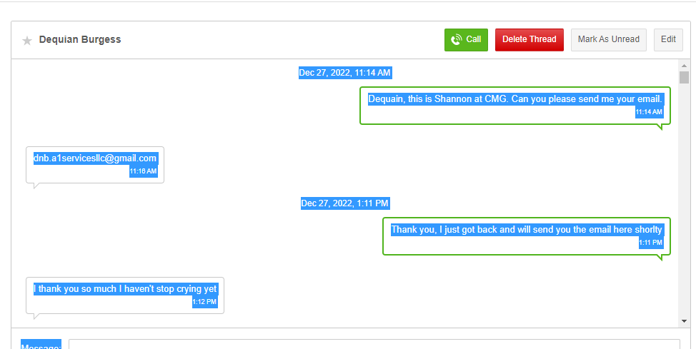

Dec 27, 2022, 11:14 AM

Dequain, this is Shannon at CMG. Can you please send me your email.
11:14 AM
dnb.a1servicesllc@gmail.com
11:16 AM
Dec 27, 2022, 1:11 PM
Thank you, I just got back and will send you the email here shorlty
1:11 PM
I thank you so much I haven't stop crying yet
1:12 PM
So much had happened in less than a mouth Invested all I had Into a woman I thought was for me but she's in love with another behind my back was living with me I just lost my home so I've been here five days and she broke me into last night
1:16 PM
I've just been praying hard and crying to empty this pain out of me
1:17 PM
I am so sorry you are going through all of this. I hope this new year is filled with many blessings for you!
1:23 PM
Attachment: 1 Image
temp.amr
1:24 PM
Dec 27, 2022, 2:20 PM
I just emailed you the information for Ice-o-matics.
2:20 PM
Dec 27, 2022, 4:41 PM
I got it I'll be there
4:41 PM
Have a good evening!
4:50 PM
You to my life Saver
4:54 PM
I'm keeping your number to show my love to you for this
4:55 PM
Dec 28, 2022, 1:32 AM

Missed call
Dec 28, 2022, 10:34 AM
Ohh I did have a one Question what's the dress Code For Tuesday dress to impress or Prep for wearhouse Work ?
10:34 AM
And Good Morning Ms Shannon
10:35 AM
Good Morning! The work dress code is casual. I always feel you should wear something business casual.
10:38 AM
Just checking
10:40 AM
I agree
10:40 AM
Good questions!
10:40 AM
10:41 AM
Jan 2, 2023, 11:04 AM
Reminder: Tour and Interview tomorrow at noon at Ice-o-matics for the 2nd shift Evaporator Assembler position. 11100 E. 45th Ave. Please confirm you can still make this- Shannon
11:04 AM
I'll be there I promise you're #1
11:20 AM
I hope it goes real well! Happy New Year!
11:24 AM
My kids and me living depending it I claim it in the name of Jesus
And happy new years to you as well
11:27 AM
I will also say a prayer for you to get this position!
11:28 AM
Jan 2, 2023, 12:48 PM
I thank you so much I
just got through saying I wanna get started getting ready so I can eat pray and head out it's only 22 minute from me with traffic
12:48 PM
Planning a head
12:50 PM
very good
12:58 PM
Jan 3, 2023, 9:15 AM
I'm dressed and ready can't get the car out of the apartment complex at IMT to slushy not enough traction to get the through it and I have to get to a station so I can make this tour and Interview
9:15 AM
I'm not going to make by 12
9:15 AM
The Dayton has work going on can't get to the tracks
9:16 AM
And good morning
9:16 AM
I'm going to try to get Uber or Lyft money to get a ride wish me luck
9:16 AM
Let me know! I hope you can make it. If not you can tour next Tuesday, but sure you are ready to work!
9:23 AM
Yes I am I need this job
9:24 AM
I just hate I need tires
9:24 AM
Let me know if cant make it so I can let HR know you are still interested. I hate getting tires or anything for my car :-)
9:29 AM
Please let them know is there a tomorrow Mrs Shannon
9:32 AM
They just need to come clear the complex of this mess
9:32 AM
They only interview on Tuesdays so if you cant go today it will have to be next Tuesday the 10th
9:33 AM
So be I'll set my alarm for two hours early if I have to walk there I'm going to make it next week is our last week to get up the money for rent in m doing my best
9:34 AM
I will put you on the list for next Tuesday at noon. I hope everything will be alright.
9:37 AM
It will be Good God got us
9:39 AM
Jan 3, 2023, 10:03 AM
It say I can be there by 12:02
10:03 AM
There's a bus that comes by at 42 after the hour like a 15 walk to it I'm going to take it
10:04 AM
I let them know you had to reschedule. If you have any problems getting in please tell tour guide to ask for Sherri.
10:06 AM
Okay
10:07 AM
Jan 3, 2023, 11:45 AM

00:36

Missed call
did you make it in? sorry I was away from my desk
12:05 PM
Jan 3, 2023, 2:35 PM
Congrats! You got the position. Are you able to do training tomorrow from 9am-3pm? I will need to email you the onboarding so that we can get you on payroll and do bkdg/drug screen!
2:35 PM
Where to go for drug screen and did you send the background to me yet
2:36 PM
No I need you to do the onboarding link so I have all your info: https://zenople.esgazure.com/login/cmg I will also email it to you
2:37 PM
Jan 3, 2023, 3:11 PM
Can I get your email?
3:11 PM
dnb.a1servicesllc@gmail.com
3:12 PM
Jan 3, 2023, 4:44 PM
I see you started the process there is 14 tabs and each has to be complete before you can go to next. Let me know if you get stumped on anything. At the end you will click on submit
4:44 PM
Yeah The site is tripping it's saying my last name is drug lol
4:45 PM
If you get stuck, I can act as you. I would need you to send me your id's and answer the questions
4:47 PM
Attachment: 1 Image

4:47 PM
Can send me your id's let me fix and we will go thru together!
4:48 PM
Attachment: 2 Images

4:49 PM
Got good news than came home to bad news my brother Ryan passed out and never got up it's all over face book same
4:51 PM
Dad
4:51 PM
Attachment: 1 Image

4:52 PM
My Best friend told me I don't have a Facebook page but good thing my friends do
4:53 PM
I am very sorry to hear this. You have been through a lot. We are going to continue this tomorrow so you have some time. We will get it done. It's not letting me log in so we will revisit after training tomorrow. In my prayers
4:54 PM
And thank you so much for being my Angel on earth you're a real blessing
4:55 PM
Your welcome
4:56 PM
Jan 4, 2023, 8:31 AM
Are you going to be able to make to training at 9am today with all you were dealing with last night?
8:31 AM
I'm just getting up sitting here up set now I was up to late dealing with Family and on top of that the car went out last night on my our car I had to go save her she was stuck off airport Blvd in the cold the power went out on the car jump after jump still no luck
8:34 AM
I'm trying to see if I can get a Lyft here fast enough
8:35 AM
It's 9:05 to late
8:36 AM
Is it to late
8:36 AM
You can try I cant guarantee you can get in if you aren't there when Hr comes to get you. Let me me if we need to reschedule for next Wed
8:39 AM
I'm about to die I need this job I'm about to break down devil get up off of me leave me be
Mrs Shannon please save my job
8:41 AM
I will see if I can get you in tomorrow otherwise you will have to wait to do training next Wed.
8:42 AM
Well anything but lose this job
8:43 AM
I sent Sherri and email, I will see what she saws. It is ok to start training next week. You wont lose job
8:45 AM
Okay please Let please
8:45 AM
Jan 4, 2023, 9:08 AM
Attendance is big with them I think I'll go through the whole process of I have too anything I'll do 20 he days I'll do it anything for them to understand I'm trying to get back to being a good man healed working hard definitely always keeping the devil away from stealing my joy
9:08 AM
You haven't officially started so they can't use the point system against you. One you complete training that is your first day and that is when attendance goes in effect. They allow folks to train a week after tour not to worry!
9:36 AM
Jan 4, 2023, 10:01 AM
OMG THANK YOU SO MUCH
10:01 AM
Jan 5, 2023, 9:57 AM
Do you have a social or birth certificate you can text a pic of. I want to try and process somethings today, while we wait to do zenople together.
9:57 AM
Attachment: 1 Image
temp.amr
10:04 AM
Attachment: 1 Image
temp.amr
10:04 AM
Can you call me real quick to get your social # Thank you- 303-920-1425
10:26 AM
Jan 5, 2023, 10:46 AM

03:14
Jan 6, 2023, 9:16 AM
I tried resetting the email login to get new password not successful
9:16 AM
Ok, I will look and see if it created a new one from the one I told you. Let me look into.
9:26 AM
Okay
9:30 AM
Jan 6, 2023, 12:30 PM
I was able to get into you profile. Please call me when you have a chance so I can ask you the questions and get this completed. Thank you!
12:30 PM
Jan 6, 2023, 1:22 PM
I emailed you the passport to get drug screen complete. If you have time this week along with all the car repairs can you please get this completed- Thank you, Shannon
1:22 PM
Yes ma'am
1:40 PM
Jan 10, 2023, 1:59 PM
did you get car fixed? Are you able to start training tomorrow from 9am-3pm at Iceomatics?
1:59 PM
I'll be starting on time I promise But I got a problem I was greedy at her Aunt's Sunday for Dinner and I put the wrong thing in my mouth I looked like a blimp Call the ambulance I was having an allergic reaction to a brownie or the cookie that I had it was THC infused I'm allergic to weeds grass leaves and most of all marijuana so I haven't been able to go anywhere I on a detox after stomach pumping at hospital worse headache ever I feel so drunk never eat a dinner at a gypsy house family I fell stretched my forehead it's small but lord it could've been Bad but I didn't know and I was hungry when we got there but I'm going to get it together and you got my word I'll be there at 8:30 because of you're not early you're not on time
2:23 PM
Jan 10, 2023, 2:45 PM
Wow, that is crazy! I will let them know you will be there tomorrow. Take care of yourself!
2:45 PM
Sorry I had to lay my head down for a second sorry about that yeah No warning ️ about the things they cook I understand it's her house but people coming over say something like her this is not for everyone dang sure not me
3:14 PM
It has thrown a rock in crank system if you know what to I do mean idk if these Detox things work idk but we will know very soon
3:15 PM
Jan 10, 2023, 3:24 PM
Very scary!
3:24 PM
Very it was hard to breathe in air
3:44 PM
So are they paying us for training and what side do I go in this time
3:45 PM
You will enter the same place you did when you went for tour. They will give you a badge tomorrow. Training 9am-3pm yes paid training.
3:51 PM
Man I need to say it again thank you for being here all the way with me but what if I wanna stay working for you is that possible man I feel like he sent you to me for a reason you're like a life line to me I can talk to you we both lost our love ones
3:53 PM
You're my Angel on Earth
3:54 PM
Thank you! I hope you enjoy working there.
3:54 PM
Jan 10, 2023, 3:57 PM
I hope so as well but just in case is there anything else in that's tasty in that pot of good jobs you're cooking
3:57 PM
I might have another position open come February when my client gets busier. Not much around the Aurroa area.
4:03 PM
Okay anything good for Denver or commerce City or Lakewood
4:05 PM
Centennial I meant to say not commerce City
4:05 PM
We have positions all over the Denver Metro Area.
4:14 PM
Jan 10, 2023, 4:39 PM
Okay cool
4:39 PM
Jan 10, 2023, 9:56 PM
Attachment: 1 Image

9:56 PM
It came
9:57 PM
Attachment: 1 Image

9:58 PM
Jan 11, 2023, 8:14 AM
Thank you!
8:14 AM
On my way in a Uber 31 dollars we have to get another car
8:18 AM
Attachment: 1 Image
temp.mp4
8:42 AM
Jan 12, 2023, 1:18 PM

03:42
Jan 13, 2023, 10:24 AM

Missed call
Good morning how do I sign up for insurance I wanna do before I'm paid so they can take the money out I broke my tooth
10:25 AM

Missed call

Missed call
Jan 13, 2023, 11:53 AM
I emailed you the forms. Do you need me to resend? The insurance will not go into effect for 30 days thouugh.
11:53 AM
Yes please put it in for me I want it no matter is there dental
11:56 AM
Yes, there is dental.
11:56 AM
Just go ahead and put it in for me I needed immediately the fast I got it a quick I can put in my notice so that they don't stress me about not being at work
11:57 AM
I am confused. You want to put in your notice? If you aren't working you wont be eligible for the insurance. Please let me know.
12:01 PM
Jan 13, 2023, 8:56 PM
I don't see the email
8:56 PM
Jan 16, 2023, 12:38 PM

Missed call
Hello! I am not in the office, Do you need me to call you?
12:47 PM
Yes, please! ‍♀️
12:49 PM
ok, give me about 15 minutes.
12:52 PM
Yes ma'am
12:53 PM
Jan 16, 2023, 1:14 PM
Tried to call you. Call me back when you can. 720-366-1885
1:14 PM

Missed call
Jan 17, 2023, 9:34 AM
Good morning any word about the insurance because me and her both needs to go her whole left side is swollen and I hardly can eat anything
9:34 AM
Jan 17, 2023, 1:50 PM

01:09
Jan 17, 2023, 5:37 PM

Missed call
Call me on my cell if you need to talk 720-366-1885
5:43 PM
Jan 17, 2023, 6:17 PM
Okay
6:17 PM
Thank you
6:17 PM
Jan 19, 2023, 11:06 AM
Did you turn in my form for direct deposits that I sent you
11:06 AM
Yes, I did.
11:21 AM
Did our payroll email you a paystub?
11:23 AM
Jan 19, 2023, 11:47 AM
Yeah but my card provider said contact you guys no payment pending
11:47 AM
Is the account number and routing you provided for a bank or another pay card? We cant transfer funds to paycards other than the ones we provide.
11:51 AM
Jan 19, 2023, 12:30 PM
It's my cash app card
12:30 PM
You get your paycheck early with them
12:31 PM
It is connected to routing for a Sutton bank. Tomorrow is our official payday. I think we will know more tomorrow.
12:37 PM
So it was no need to use my bank huh no more early payment form you guys I'm guessing
12:40 PM
We can only take bank direct deposits and not other paycards. It is up to each bank how they pull funds. I guess we will know more tomorrow with it being pay day.
12:42 PM
Jan 20, 2023, 8:57 AM
Good morning I didn't get paid
8:57 AM

02:21
Will you email me your account info again so I can double check we have the correct information. shannon@corpmgmtgroup.com
9:18 AM
Jan 20, 2023, 9:57 AM
I'm going to have to call in because I'm tapped on funds I Uber everyday if I don't pay a CO worker for a ride home idk what to do if I can come pick up a paper check I'll walk to the location so I can get to work having to wake up early is hurting me to handle things I need my rest but I can't until things run smoothly for me it's rough but I think you I really do Angel from above
9:57 AM
I am sorry about this. Our payroll department is not in Colorado. That is why I am tryin to get this resolved today to get you funds. I may be able to put on one of our paycards. Waiting on payroll for a solution.
10:05 AM
Okay
10:09 AM
If that had to be my form of payment so be it
10:10 AM
I have to figure something out I go to work in a little bit or comes great I can't even go back to sleep or I'll miss it I'm super tired
10:11 AM
Jan 20, 2023, 11:27 AM
Please confirm routing 041215663 acct # 12866440444838
11:27 AM
If we don't figure this out today it will only delay pay.
11:32 AM
Jan 20, 2023, 12:14 PM

02:52
Jan 20, 2023, 12:56 PM
I called her to let them know I can't make it hopefully this gets figured out two weeks no money really hurts I'll take a CO pay card from here on out
12:56 PM
Jan 20, 2023, 2:32 PM
We are working on getting wire transfer tracking number that you should be able to get to your bank to show we are trying to send funds.
2:32 PM
0073901230000824 is the trace # to give to your bank to show we have been trying to send your funds. They should be able to help you from there. Please let me know if this works.
2:39 PM
Jan 20, 2023, 3:33 PM

08:43
Jan 23, 2023, 8:22 AM
Can you please call me at 720-366-1885. Your bank rejected the funds and now we can get them on a new paycard. Thank you, Shannon
8:22 AM
Jan 24, 2023, 5:43 PM

Missed call
Call me please
5:44 PM

Missed call

New Voicemail
00:00
My check is not right I went no tax
6:03 PM
Jan 24, 2023, 7:14 PM
Call me if you need to. If you went exempt there will still be medicare and social security taken out. 720-366-1885
7:14 PM
Jan 25, 2023, 2:05 PM

Missed call

New Voicemail
Hey, this is the queen. I tried to call and I can't get in touch with you. You always me when I'm on the ground. I mean on the floor at work. Uh Can you call it if they got another opening position? If not can you tell me what job do you have available? So I can I can make me a selection. I don't care where it is. I'm just I don't want to keep doing this same. Thank you man, this ain't this ain't what's up. I mean they they tell you one thing before they hire you and then you get hired this same, it's a lot, you know what I'm saying? So I don't want to be a company that's liked it. So I think it's best for me to either just try to contact you or just, you know, find another work for me. So if you can please call me back Miss Shannon. I mean like it's immediate as possible because I I can't really be on the floor talk. I'm trying to get in contact with you. I got I was just tedious. I can't do nothing in the daytime because I have the rest in order to make it through the night of this shop. So if you can please call me back, please don't text me call me. Thank you
00:00

Missed call

Missed call
Jan 25, 2023, 3:56 PM

Missed call
Jan 27, 2023, 11:26 AM

Missed call
Barrett McConnell 303-576-3083
11:32 AM
I will send a message to Sherri letting her know you may be late due to dentist appointment. I sure hope you feel better and can get relief soon!
11:35 AM
Thank you he didn't answer I left a massage hopefully it works
11:36 AM
I hope we can get in today to be helped if not we going to the er
11:37 AM
That is fine you left a message. Like I said I follow up with Sherri in an email so that you are covered. I hope you don't have to go to emergency.
11:39 AM
Jan 30, 2023, 11:03 AM

Missed call
Jan 30, 2023, 12:37 PM

02:19
Jan 30, 2023, 1:16 PM

01:53
We were informed if you need to call to let someone you will be late or not in to contact Evaporators 2nd Shift Contact: Barrett McConnell 303-576-3083
1:21 PM
No answers at no number only up front for sells
1:23 PM
If you at least leave a message they will get it eventually and have a time stamp that you made the effort to call.
1:27 PM
In the Uber now leaving the dentist office I'm going to leave her there hopefully they were allow her to take whatever they're going to give her at home versus to administering it to her there so yeah I'm on the way
1:38 PM
Jan 30, 2023, 3:17 PM
The closest Urgent care is 3001 Havana Street (Care Now Urgent Care) open until 5pm. Please make sure you get discharge paperwork as this is something I will need for you to return to work.
3:17 PM
Let them know you are with Employer Staffing Solutions. My coworker Lauren will need to ask you some questions regarding the incidence tomorrow when she comes in. Please let me know how you are doing. Shannon
3:18 PM
Jan 30, 2023, 4:00 PM

11:12
Jan 30, 2023, 6:06 PM

Missed call
Jan 31, 2023, 10:39 AM
Hi Dequian, this is Lauren. I will be overseeing your Work Comp Claim. I will be calling you around 11am to go over paperwork.
10:39 AM
Jan 31, 2023, 11:42 AM
Attachment: 1 Image

11:42 AM
Thank you!
11:59 AM
You're welcome Ms Lauren
12:01 PM
Jan 31, 2023, 12:18 PM
Hello! Shannon here. I hope you are feeling some relief today and getting some rest. I am going to email you information regarding cancelling insurance. Thank you!
12:18 PM
It kicks in one week
12:21 PM
We used our company insurance
12:21 PM
They cutting it off her mouth Wednesday
12:22 PM
How are you feeling today
12:22 PM
Feb 2, 2023, 2:18 PM
Were you able to make it to the urgent care>
2:18 PM
Feb 2, 2023, 4:07 PM
Attachment: 2 Images

4:07 PM
Feb 2, 2023, 6:02 PM
Can you please in an email. I cannot read any of the reports. Shannon@corpmgmtgroup.com. Are you at the ER now?
6:02 PM
Feb 2, 2023, 7:33 PM
Attachment: 2 Images

7:33 PM
Can you please send to my email shannon@corpmgmtgroup.com\
7:39 PM
Feb 6, 2023, 9:20 AM
Am I good for work before I order my Uber
9:20 AM
Does your paperwork state you are clear to work with no restrictions?
9:30 AM
Monday
9:31 AM
Today is Monday right or am I still los on my days
9:31 AM
Not the best weekend for me
9:32 AM
Today is Monday. Do you have paperwork stating you are clear to work?
9:33 AM
I'm sure what you are meaning the last doctor said after the exam he not see nothing
9:34 AM
We need to see paperwork that you have been cleared by a doctor to return to work. If he is not seeing anything, do you have documentation stating this?
9:35 AM
So go to the first place to get cleared man this is a lot on me I've spent a lot of money I didn't have on this back and forth thing so yeah I have to go Uber to go get cleared for work
9:36 AM
I'll get up and get ready now so I can be on time for work
9:36 AM
Feb 6, 2023, 9:52 AM
Please wait for me to advise if you are cleared to return to work. We are requesting documentation stating you are cleared. You will not need to drive anywhere to get paperwork. We are waiting on the medical facility to respond.
9:52 AM
Well I just asked my girl if I had to go see some one she's said yeah they old place I don't remember as I said not there best week some much done happened that I'm about to lose myself seriously I need to work if not there somewhere please
9:56 AM
You were supposed to go back to the urgent care on 2/3 on Havana for a follow up appointment. They stated you didn't show. You will need to go back to that urgent care to get cleared before you can return to work.
10:12 AM
Not what the paperwork say but okay I'll get up and dressed and Uber there after that I need to go get an id so I can get some Colorado help I can't with my fl id
10:15 AM
Then try to get to work
10:15 AM
Feb 6, 2023, 10:30 AM
We will need the documentation from you or the urgent care to state you are released to return to work.
10:30 AM
I'm getting ready
10:31 AM
Feb 6, 2023, 12:14 PM

01:58
Feb 6, 2023, 1:41 PM

03:48
Hello Dequain! I had a chance to connect with your Work Comp Representative, Snotti Jappa. She is the person handling your case and will be able to assist you with the issues you are having. Please contact her directly at 952-767-8043
1:53 PM
Message:
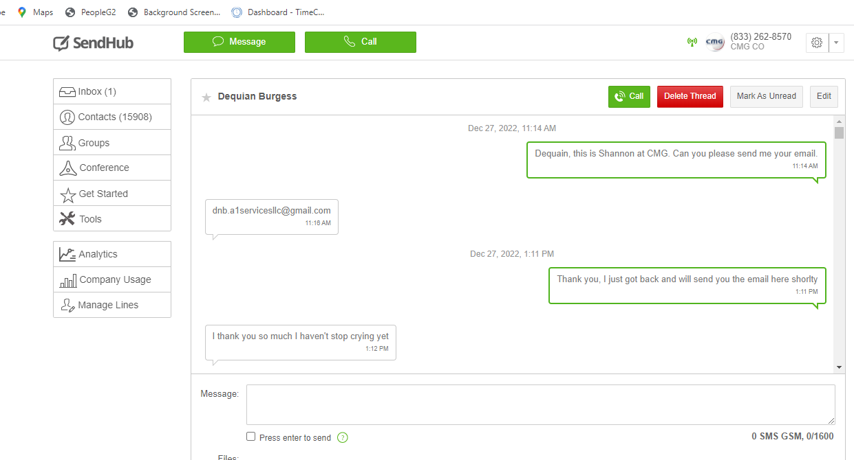

As far as I can see I won't be working until it's over
12:18 PM
Mark as Unread Save as Template Forward
Message:
0 SMS GSM, 0/1600
Press enter to send
Files:
Send

