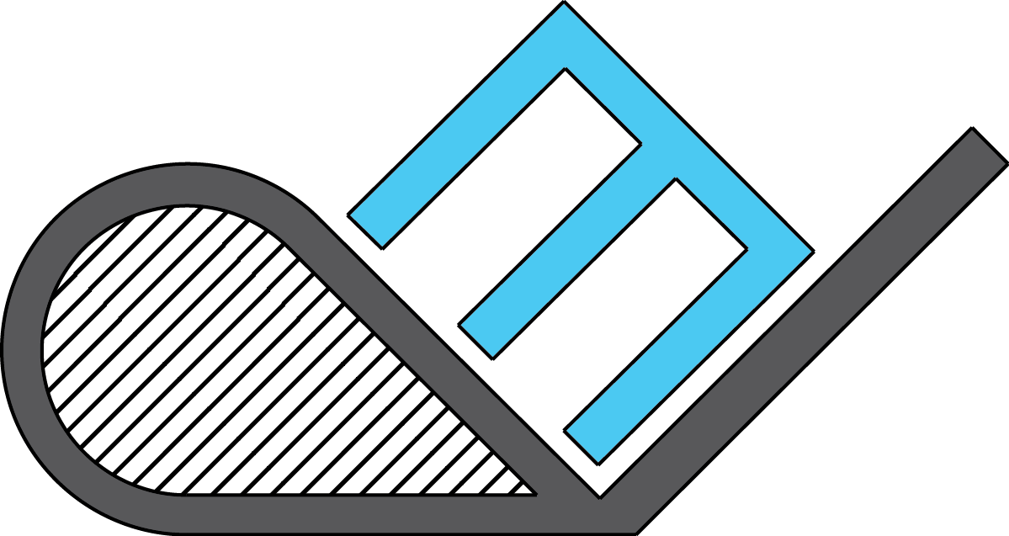

MASON E. DELONGPRE
8636 Scenic Green Circle, Apt. 11104 Fort Worth, Texas 76244
817-948-0819 masondelongpre@gmail.com

Professional Objective
To focus mainly in mechanical design using SolidWorks, AutoCAD, and similar software to design, build, and test mechanical parts, products, and vehicles. Desire to gain higher knowledge with hands-on processes including injection molding, woodworking, rapid prototyping, welding, and machine shop skills.

Experience
Past experience gained from SAE Collegiate Design series building off road vehicles from AutoCAD sketches to fully built cars. Designed projects in the classroom requiring hands-on experience with injection molding techniques and rapid prototyping procedures such as 3D printing. Welding experience, assembly skills, and machining methods were gained during final project of designing and building a wood burning gasifier.
Current experience is in gas and liquid pipeline engineering. Tasks include pipeline design, engineering calculations, assembly of material lists for procurement, and composing issue for bid and construction packages. Competencies include development of flow diagrams, editing alignment sheets, generation of relief valve sizing reports, and contribution to pipe sizing and FEED studies. Attended a SynerGEE hydraulic modeling software course and supported pipeline design for gas and liquid gathering systems in the Barnett Shale play.

Achievements
- Assisted with multiple oil and natural gas projects with editing piping and instrumentation diagrams, as-built drawings, and equipment diagrams.
- Created FEED studies and designs using SynerGEE water hydraulic software for simulation of pipe sizing on approximately 100 miles for a salt water gathering system and central facility.
- Attended a SynerGEE class and received certification in Standard and Advanced Water Modeling. Course included work in pump controls, tanks and reservoirs, model building, steady-state analysis, and water quality.
- Supported pipeline design for gathering systems in the Barnett Shale by reviewing construction design drawings.
- Developed hydraulic models for natural gas systems in Eagle Ford Shale play using PipePhase software.
- Developed pipeline design of freshwater and produced water gathering systems in the Eagle Ford and Bakken Shale plays.

Skills
Knowledge of Solidworks, AutoCAD, Inventor, 3DS Max, ArcGIS, Microsoft Office, Adobe Photoshop, Pipeline Toolbox, Google Earth, Java, C++, and SynerGEE Water. Strengths include interaction with third parties, such as clients, vendors, and subcontractors, which fuels leadership and problem-solving capabilities. Experience from working in small project teams has greatly enhanced the ability to meet required deadlines.

Education

2007-2011
Bachelors of Science
Mechanical Engineering
Robert Morris University
Cum Laude, May 2011
Overall GPA: 3.54

Awards
Robert Morris University Dean’s List
Robert Morris University Merit Scholarship
U.S. Steel Corporation Scholarship

Certifications
SynerGEE Water Standard &
Advanced Modeling

Previous Employers
Walgreens Drug Store 2005-2009
Willbros Engineering 2011-Present
Clubs
SAE Baja Collegiate Design Series
2007-2008

Courses
Physics (I,II), Thermodynamics, Dynamics, Fluid Mechanics, Engineering Graphics, Engineering Materials, Numerical Methods, Circuits & Electromagnetics, Robotics, Machine Design, Heat Transfer, Integrated Engineering Design

Internship
Researched and designed rapid prototyping techniques as well as a mold to be used with injection molding machines

