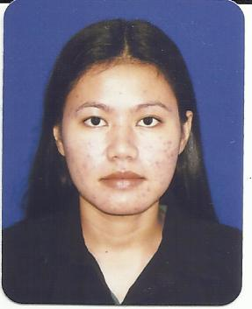
KRISTIAN P. ALBERTO
Blk 33 Lot 9 Phase 2 Golden City Subd. Dasma 1 Dasmariñas Cavite Philippines
Mobile No: 09478276207
Email Add: kiana_jap@yahoo.com

Objective: To be able to work appropriately and my potential to the fullest as I acquire more knowledge and skills in a new and dynamic working environment.
Personal Data:
- Date of Birth : July 20,1986
- Birthplace : Manila
- Citizenship : Filipino
- Sex : Female
- Civil Status : Single
- Religion : Catholic
- Height : 5’5
- Weight : 110 lbs
- Dialects Spoken : English, Tagalog, Bikol

Educational Background:
- Primary: Barcelonita Elementary School
SY 1993 – 1999

- Secondary: Barcelonita Fisheries School
SY 1999 – 2003

- College: Mariners Polytechnic Colleges
2yr Hotel and Restaurant Management
SY 2006 – 2008
Specific Skills:
- Computer Literate.
- Operate large automatic multi-needle machines to embroider.
- Check fabrics or products for defects.
- Repair minor mechanical problems such as broken or defective needles.
- Notify supervisor or repairers of mechanical malfunctions.
- Fast and accurate.
- Investigate machine stoppages.
- Make adjustments to machines.
- Working with others.
- Knowledge of basic arithmetic.
- Skill in handling and counting cash.
- Skill in communications with public.

Job Experience:
- March 2010 – March 2012: Long Chang Oversea Co., Ltd.
Machine Operator
Shanhua Tainan, Taiwan

- November – December 2009: Kyowa
Promodizer
Market Market Taguig

- April – October 2009: Howzat Sports Bar
Cashier
Kalayaan Ave. Makati City

- April ’08 – April 2009: Ronak Taxi
Cashier
Tandang Sora, Quezon City

Character References:

- Alfie Pagdalian
Machine Operator
Long Chang Oversea Co., Ltd.
Taiwan ROC

- Shirley Dellosa
Operation Manager
Howzat Sports Bar
Makati City

- Racquel Montero
Hrd Staff
Big Apple Holdings Corp.
Malate Manila

I hereby certify that the given information are true and correct to the best of my knowledge and belief.
Kristian P. Alberto

