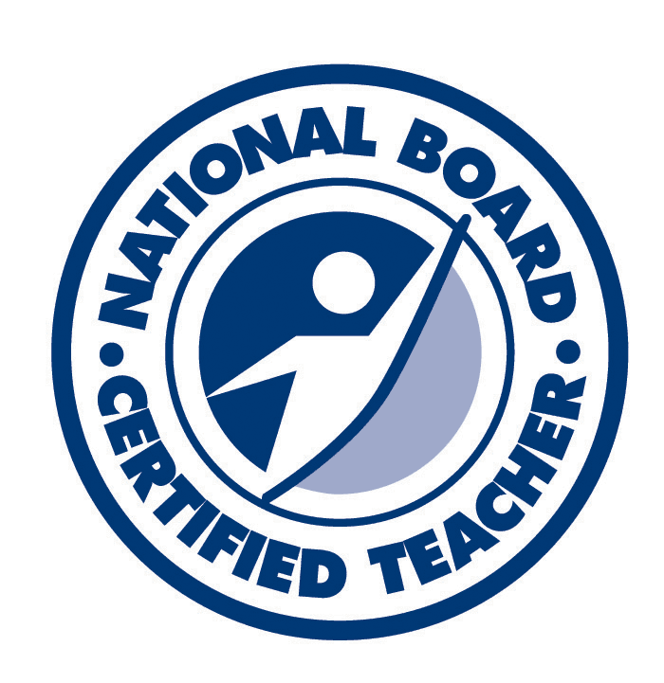
Kevin M. Youngberg, NBCT
2575 Shannara Grove
Colorado Springs, Colorado 80951
(719) 963-9074
teachingchem@yahoo.com

Objective
My objective is to gain a position of employment as I transition from teaching high school science for the last 12 years into a professional science career.

Achievements
Upon graduating from the National Board Certification Program in District 11, I was awarded National Board Certification within only one year (typically a three year process.) (2012)

National Board Certification confers the Master Teacher designation in the State of Colorado. (2012)

Student nomination for the Rotary Club’s Teacher Diamond Award including the statement, “Every day I come into class knowing I will learn something important for my future.” (2012)

My students earned the exemplar Advanced Placement Chemistry Exam average score of 4.16 / 5--Highest score and average passing rate in recorded Coronado High School history. (2010/2011)

Chemistry Olympiad team member advanced to the National level of competition under my advisement/training (2011)

I implemented Advanced Placement Chemistry at Sand Creek High School for the first time in school history. (2009/2010)

I was honored by a student at a 3.75 GPA Student Recognition Dinner as the teacher who most influenced their academic success (2009)

I accomplished exemplary passing rates (96% or higher) and average student achievement (80% or higher) on the New York State Biology Regents Examination (2001-2004)

Bachelor’s Degree with Cum Laude honors at the State University of New York College at Brockport

Qualifications
National Board Certified Teacher License
Colorado State Professional Master Teacher License in Secondary Science
New York State Teaching Licenses: General Science, Biology, Chemistry

Education
National Board Certification Program
Completion of District 11 ‘NBCT Reader Course’ and ‘NBCT Facilitator Course’ providing the training necessary to support NBC candidates and create a National Board program in a district. -1 graduate credit each: Spring 2013
Completion of two NBCT courses to demonstrate my continued application of NBC principals of accomplished teaching-9 graduate credits: Fall 2012
D11 NBC Program-8 Saturday classes earning 4 graduate credits, Portfolio Submitted: March 2012, Assessment Center Exercises: June 2012
Advanced Placement Chemistry Trainings
New Teacher Training: November 2008, AP Summer Institute: July 2009, Experienced Teacher Training: November 2009, Experienced Teacher Training: March 2010
Post Graduate Credits Earned at Various Universities and Colleges
‘Inquiry in the Secondary Science Classroom’-2 credits, ‘Real-time Weather’-3 credits, ‘The Environment and the Economy’-2 credits, ‘College Board Sponsored Advanced Placement Chemistry Summer Session’-2 credits, ‘Safety in the Science Classroom’-1 credit, Advanced Technology Courses (3)-1 CDE credit each
Master’s Degree in Secondary Science Education with a concentration in Biology
State University of New York College at Brockport, Brockport, NY
Graduation: August 2005 GPA: 3.92 / 4.0
Bachelor’s Degree of Science, Major in Biology, Minor in Chemistry
State University of New York College at Brockport, Brockport, NY
Graduation: June 2001 GPA: 3.37 / 4.0

Professional Teaching Experience
Science Teacher, Mesa Ridge High School, District 3, Colorado Springs, CO
2012-2013 Taught College-Preparatory Chemistry and Earth Science
Science Teacher, Coronado High School, District 11, Colorado Springs, CO
2011-2012 Taught College-Preparatory Chemistry, Honors Chemistry
2010-2011 Taught Physical Science, College-Preparatory Chemistry, Honors Chemistry and AP Chemistry
Science Teacher, Sand Creek High School, District 49, Colorado Springs, CO
2009-2010 Taught College-Preparatory Chemistry, Honors Chemistry and AP Chemistry
2008-2009 Taught Zoology, Freshman Seminar, College-Preparatory Chemistry, Chemistry II
2007-2008 Taught College-Preparatory Chemistry, Biology, Freshman Seminar and Remedial Biology
2006-2007 Taught Integrated Science and Biology
2005-2006 Taught Integrated Science and Biology
Science Teacher, Falcon District Summer School, District 49, Colorado Springs, CO
2009 Taught an Online/Laboratory hybrid science class for students ranging from 8th-12th grades
2008 Taught two Biology classes-1st and 2nd semester
2007 Taught two Integrated Science classes-1st and 2nd semester
2006 Taught 8th Grade Mathematics
Science Teacher, Falcon District Alternative High School, Night School, District 49, Colorado Springs, CO
(Concurrent with fulltime teaching positions)
2008-2009 Taught Integrated Science, Biology and Physical Education
2007-2008 Taught Integrated Science and Ecology
Science and Technology Instructor, Rochester Museum and Science Center, Rochester, NY
2005 Instructor for BUBL (Bathysphere Underwater Biological Laboratory) project
Science Teacher, Spencerport High School, Spencerport, NY
2001-2004 Taught Biology

Professional Duties
2012-2013 Science Club Advisor, Regular participation in D11 NBC program including reading a candidate’s entry
2011-2012 Homecoming Parade Marshall, Implemented the first Adventure Club in school history (including volunteering and noncompetitive activities), Created a positive behavior referral and adapted it’s use as a postcard for school-wide use (741 distributed Nov.-March)
2010-2011 Implemented the first Ski Club in school history, Formed and trained 10 students on the first Chemistry Olympiad Team in school history, Designed an academic field trip to the Air Force Academy Chemistry Department
2009-2010 Ski Club Advisor, Ticket taker at football games, Volunteer sponsor of chemistry after school review sessions, Designed an academic field trip to the Air Force Academy Chemistry Department
2008-2009 Ski Club Advisor, Ticket taker at football games, Accountability Committee Member, Prepared the Sand Creek High School Science Department for Advanced Placement Chemistry, Chaperone for Prom
2007-2008 Ski Club Advisor, Ticket taker at football games, Chaperone for the Homecoming Dance
2006-2007 Ski Club Advisor, Taught an additional class (totaling seven) to assist with classroom overcrowding
2005-2006 Ski Club Advisor, Volunteer for Student Council ‘Cookout’ for Spirit Week
2003-2004 Sophomore Class Advisor, Biology Department Spokesman and Minute-taker, Science Safety Committee member, Block Scheduling Committee member, Chaperone for French Club’s trip to France and Spain, Chaperone for Science Exploration Day
2002-2003 Biology Department Spokesman and Minute-taker, Spencerport HS Safety Committee member, Block Scheduling Committee member, Chaperone for ‘Physics Day’ field trip to Six Flags Amusement Park
2001-2001 Completed New Teacher Seminar Series of Professional Development, Chaperone for ‘Physics Day’ field trip to Six Flags Amusement Park

Use of Technology
Computer Simulations-Guided inquiry style activities including PHET simulations.
Vernier Probeware-Enabling real time data collection to facilitate full inquiry laboratories
Teacher Website-Daily agendas/calendar, Science journal database links, Course objectives and materials
Clickers-Integrating clicker technology into lessons to more effectively access student progression in learning
Podcasting-Use of podcast lectures for AP Chemistry to free up class time for extended laboratory investigations and advanced problem solving
Streaming Videos-Presentation of short videos to supplement lessons and provide real world connections to a lesson

Professional Associations
Member of the Colorado Chemistry Teachers Association
References Available Upon Request

