objective

Seeking part-time/full-time employment in an area I can use what knowledge and skills I have developed in school and my working experience. I want to advance my career in a position I enjoy and have many opportunities to become successful. I hope to further my education and become a valuable member of your work force.

Functional summary

I have computer and video knowledge, lighting and sound experience with high school productions, janitorial service, landscaping skills, library experience, and some art experience. I have great people skills, I have very good manners, and I am a quick learner. I also have great customer service skills, always have a positive attitude, and have volunteered at the Hays Public Library in Kansas and the Fort Lupton Public and School Library for a total of 5 years. I was President of the Fort Lupton Library club TAG, which is a community service group dedicated to assisting in the welfare of the community and education, which I had been attending between Aug. 2009-Oct. 2012.
Employment

March 2012-Oct 2012 Coyote Creek Golf Course
Washing, parking, and keeping golf carts in order, taking out trash around club house, picking range and cleaning balls, anything asked of me, setting up for tournaments early in the morning, helping anyone who had questions, and lifting heavy loads.
Supervisor: Pat Marek-(303) 489-8971
May 2011 - Oct 2011 Fort Lupton Library
Checking in and out books, labeling, printing and faxing for patrons, sorting and shelving books, running the computers, helping patrons with any problems they are having, and helping with any activities that the library had scheduled.
-Supervisor: Norma Muse-(303) 857-7180
June 2010 - Aug 2010 Weld County Employment Services
Maintenance and janitorial work including cleaning, fixing furniture, fixing and cleaning 500 lockers, replacing ceiling tiles, and general upkeep of school and equipment.
-Supervisor: Bob Reyes-(303) 857-3200

Education

Fort Lupton High School 2008-2011
GED Graduate Feb. 2012

REFERENCES

Crista Chadwick
425 S. Denver Ave
Fort Lupton, Co
(720) 413-8644

Bob Zebroski
Jewell Ave.
Lochbuie, Co
(303) 659-4708

Scott Asper
Thorton, Co
(303) 255-3058

Kevin Dunham
Brighton, Co
(303) 807-5974

Daniel Roberts
Oklahoma Christian University, Ok
(720) 375-2200

Reid Jones
13515 Thorncreek Circle
Thornton, Co 80241
(303) 457-1198

Chad Landers
Denver, Co 80642
(303) 582-4134

Letters of Recommendation
1

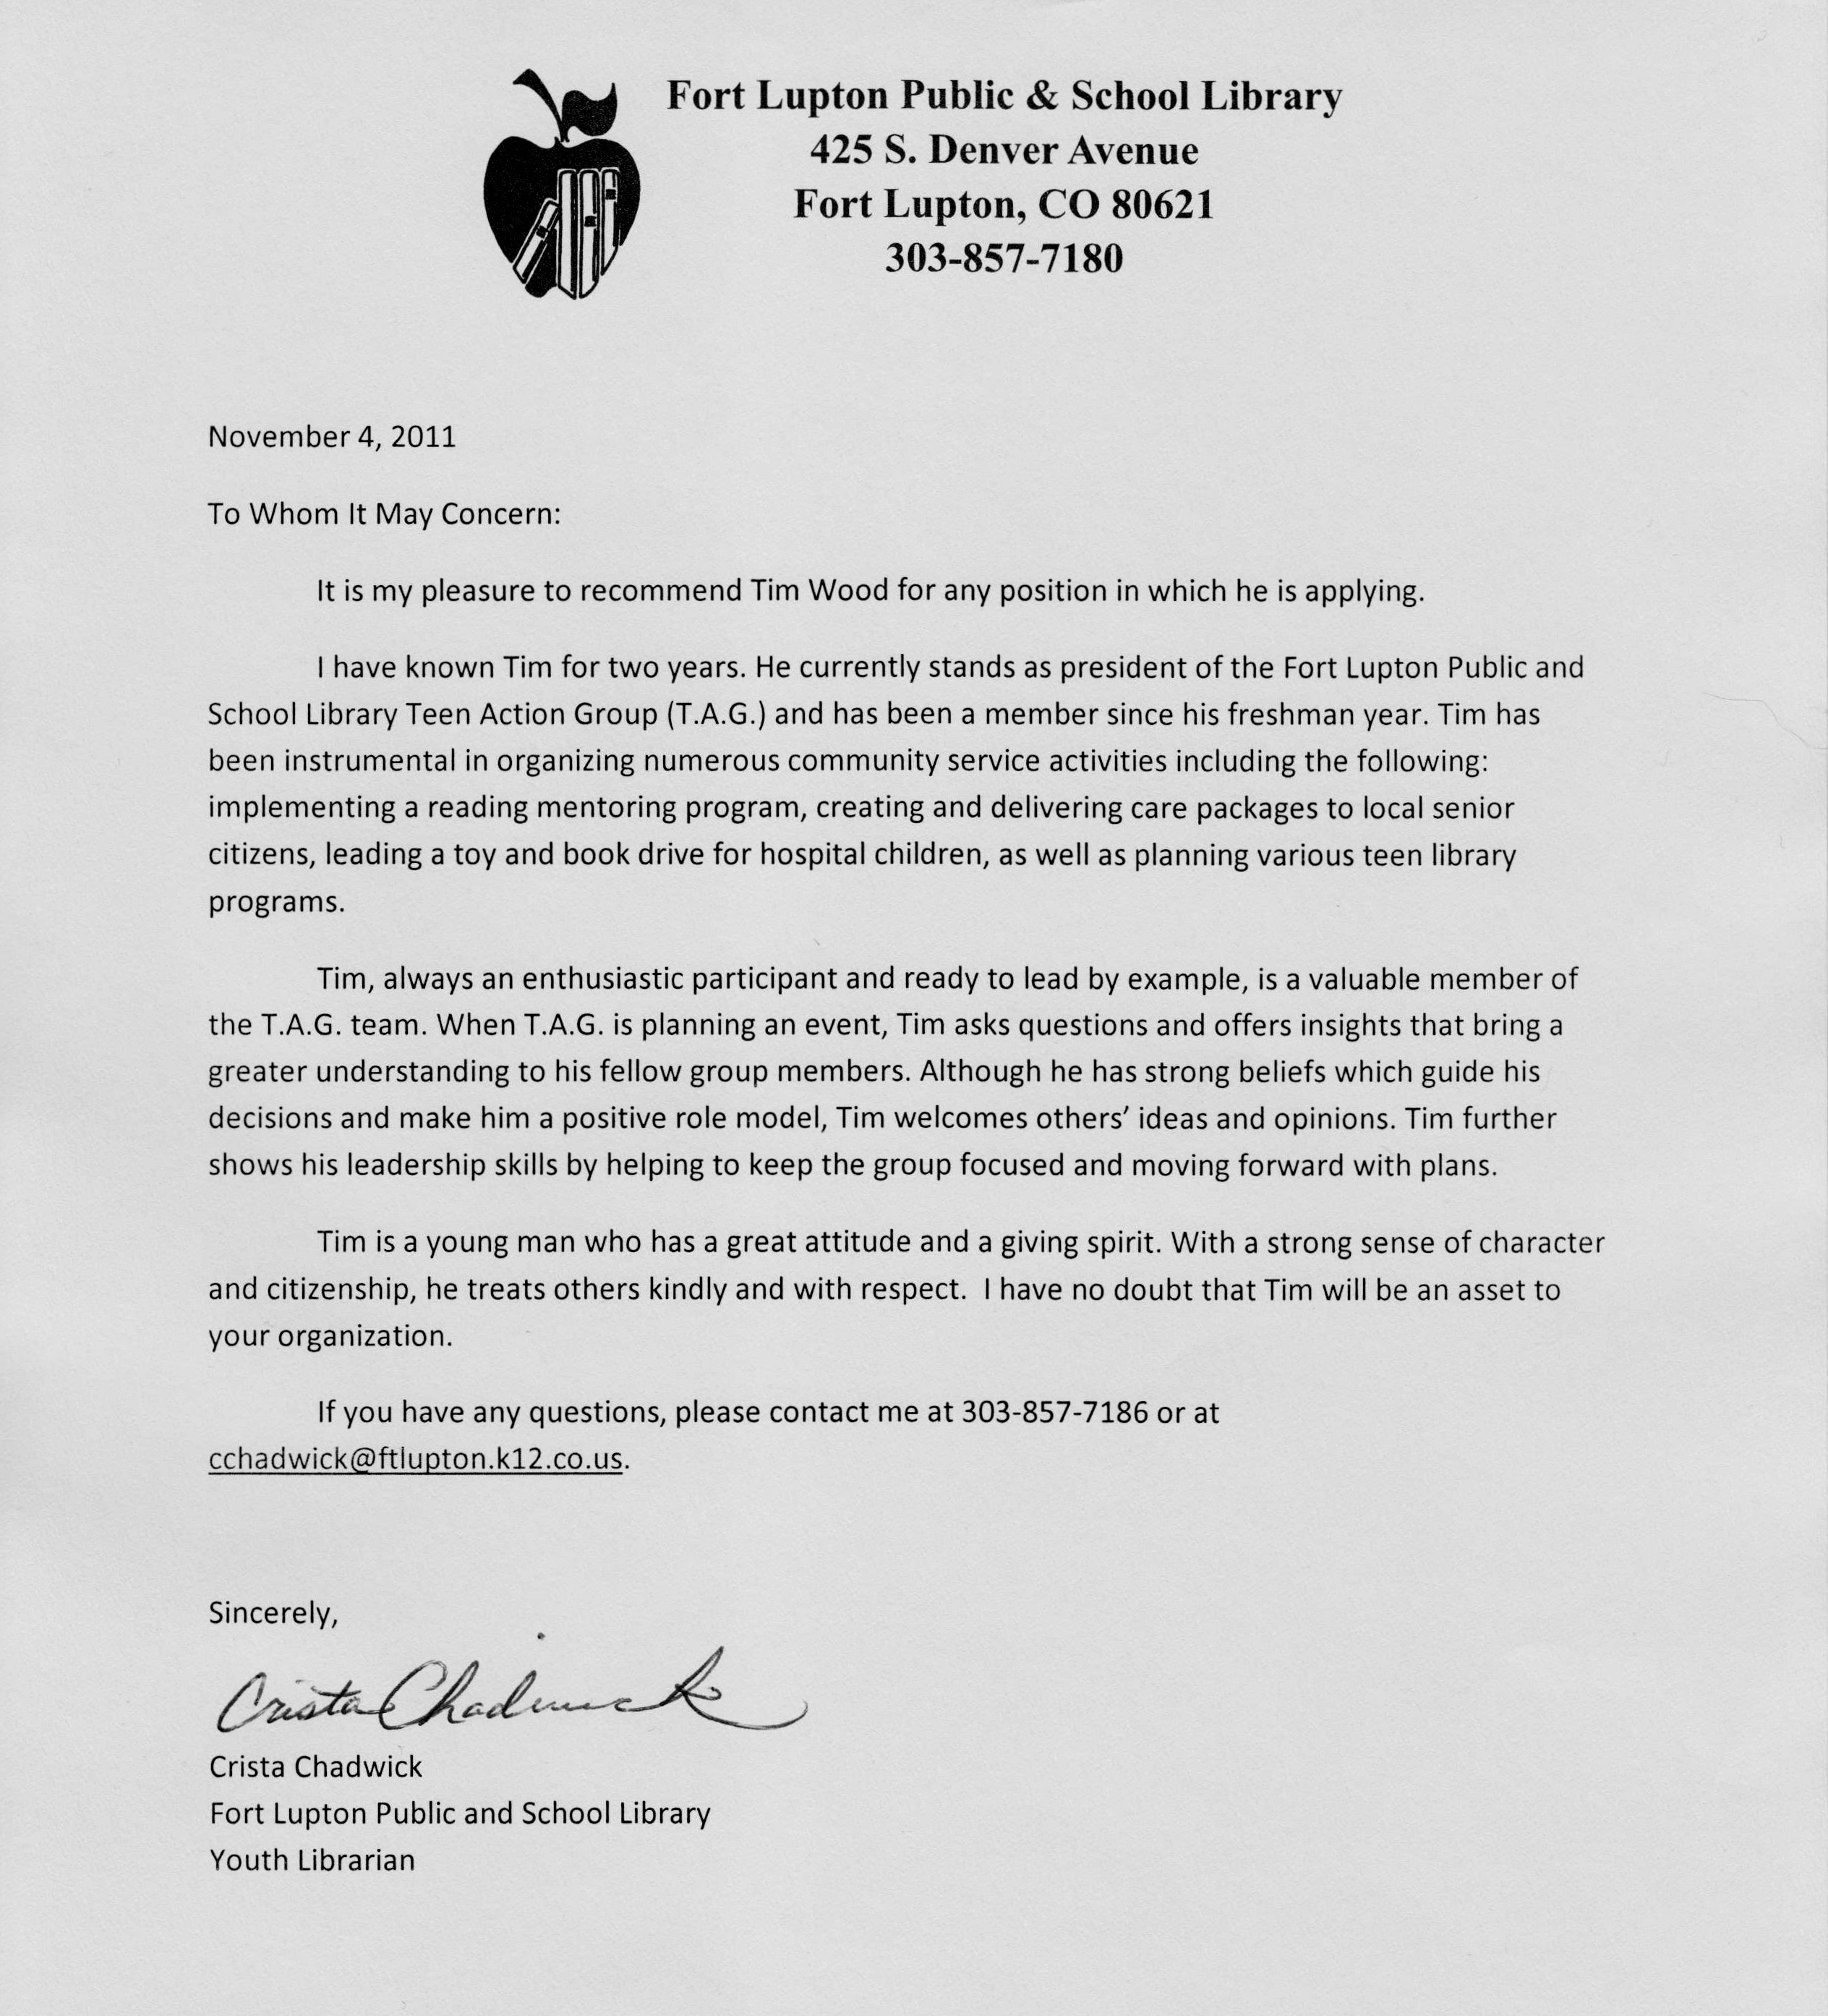

2
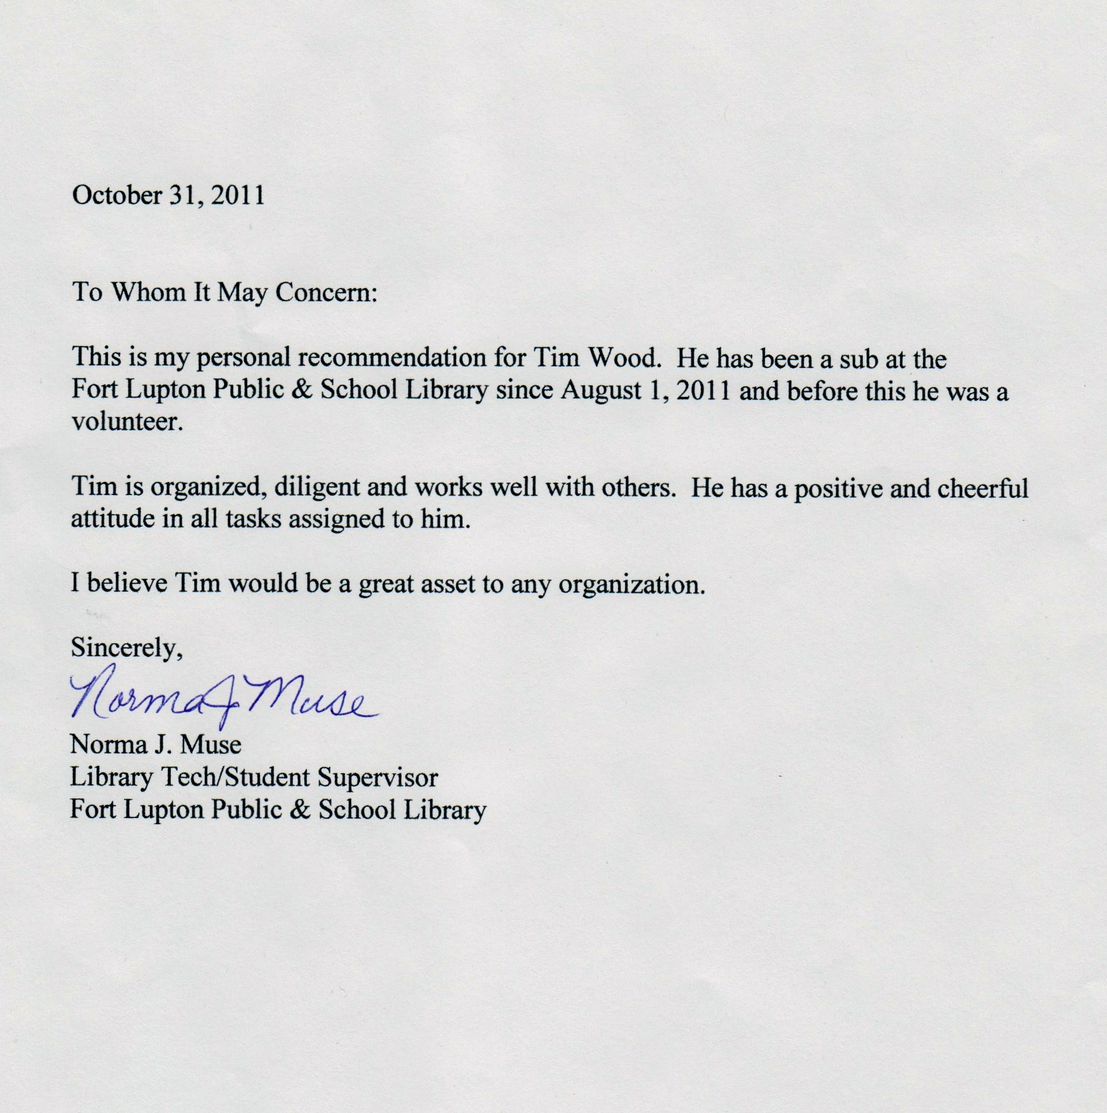

3
Will be available soon if needed.

