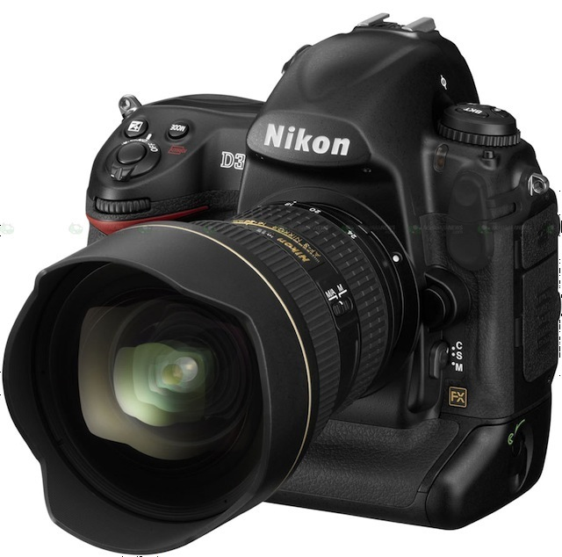Jeffrey C. Spettel
jeffspettel@hotmail.com
937-901-9637
Customer focused, Freelance Photographer and Commercial Artist

PROFESSIONAL PHOTOGRAPHY EXPERIENCE
(2005 – Present) Freelance Photographer
- Identifies needs of customers through consultations, relationship building and knowledge of digital imagery
- Coordinate and book photo shoots; completes organization, development, and layout of photo designs
- Effectively introduce product lines, analysis of operations and advertising growth opportunities

Education
Kaplan College Dayton Campus (formerly known as Ohio Institute of Photography & Technology)

(April 2012) Associate of Applied Science, Photographic Technology
Areas of Specialization: Commercial & Portrait Photography

Skills
Computer Experience and Knowledge:
- Macintosh & PC Operating Systems
Microsoft Word, Microsoft Excel, Microsoft PowerPoint
- Software Applications Skill Sets
Adobe Illustrator, Adobe Bridge, Adobe Photoshop CS3 & CS5, Adobe Light Room, Leaf Software, Capture One,

Professional Equipment Experience:
- Cameras
Nikon D40, Nikon D90, Canon 5D, Aptus Digital Back (4x5) medium format
- Lighting
Elichrome, Lumedyne, Sunpak, Photogenic, SB600, Metz 50 AF-1, 5n1 Promaster Systempro,
Profoto Acute 2R Power Pack

Photo Shoots:
- Assistance Skills
Setup and pack equipment, metering and ratio setting, and equipment troubleshooting

Photography Achievements and Awards
- 2010 Portrait Achievement Award Kaplan College (OIP&T)
- 2011 Portrait Excellence Award Kaplan College (OIP&T)
- 2011 Portrait Student Choice Award Kaplan College (OIP&T)
- 2012 (2) Commercial Gallery Awards Kaplan College (OIP&T)

Employment History
(9/2013 to 11/2013) (Full Time/Seasonal) Groundskeeper/Irrigation Tech) Reunion Metropolitan District
(2/2013 to 8/2013) (Part Time) Groundskeeper Buffalo Run Golf Course
(4/2012 to 11/2012) (Part Time) Groundskeeper Country Club of the North
(9/2011 to 11/2012) (Part Time) Janitor Far Hills Lodge #0784
(1/2008 to 8/2009) Recycler/Airpark Support ABX Air Inc.
(9/2007 to 1/2008) Picker/Puller-Warehouse Loveland Pet Products
(10/2005 to 9/2007) Assistant Superintendent Shaker Run Golf Course
(8/2000 to 8/2003) Groundskeeper, Asst. Mechanic and Head Mechanic Shaker Run Golf Course

