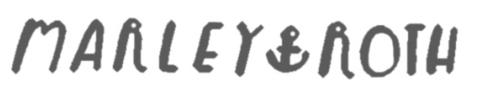

6526 S Cherry Way, Centennial, CO 80121
Home: 720.488.7790 Cell: 720.560.6980
marleyroth@gmail.com

OBJECTIVE
Interested in full-time customer service position where I can grow in my career while being able to use my previous customer service skills.
EDUCATION
Littleton High School Littleton, CO
Graduated May 2013, GPA 3.36
High School Awards: Highest Honor Roll – Fall & Spring 2012, Spring 2013
Scholastic Art Contest - Silver Key Winner, 2012
Continental League Art Show - 2nd Place in Mixed Media, 2013
EXPERIENCE
Starbucks Coffee Company, August 2012 – March 2013 Centennial, CO
Barista
- Made coffee beverages as a certified barista using a Mastrena espresso machine
- Worked on register, handled cash as well as distributed tips
- Performed opening and closing duties in a busy café setting
- Performed numerous tasks at once
- Helped train and supervise new team members
- Thrived in a high volume & high stress environment

Noodles & Company, May 2012 – August 2012 Centennial, CO
Noodles Ambassador (FOH)
- Worked register, handled cash and credit transactions promptly
- Maintained high standards of customer service in a high-volume & high stress environment
- Followed procedures for safe food preparation, assembly, and presentation
- Made sure the dining area was up to restaurant standards
SKILLS & INTERESTS
- Creative and artistic mind
- Strong speaking, multi-tasking and customer service skills
- Friendly, fun, and positive attitude
- Previous food handling & beverage preparing skills
- Strong contributor to a team working environment

