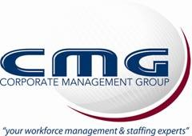

Raymond Romero

Experience

CNC Operator
Apr 2016 - Oct 2018
LA Woodworks
Run CNC
Saw’s
Logistics
Shipping/Receiving of materials
Working the forklift

Education
Aims community college
2008
Fire science

