Paul Isaac Kelly I l l

Professional Electrician.. 4th yr.APE/1st yr.JW
I'm a highly motivated individual with long term potential.l'm smart and good at everything I say I am .l'm looking to find a long term situation into a profitable one with the work that's done by me.l'm a self starter with leadership skills . 1 want a wage that reflects that care and diligence that's brought to the company I value and know without a doubt that I'm doing my best everyday and roll with the learning curves so I can keep moving forward in my career...Or a easy way of saying 'Be good,or b good at it".

Experience

4th yr.lead
Weifield group
July 2017 - Nov 2017
Project-MSU AEROSPACE and engineering building.GC-GH PHIPPS
I was in charge of 4th floor power .meaning emt racks that went almost
400 ft.total in an exposed ceiling ,ordering wire ,and planning all layout. Before any work was done .racks were 18 conduits in number so there were a lot of Homers as well as all the branch circuits and devices...also installed gutters where it maximized effeciancy and ran the linch emt for the data as well..All by myself I did this and I did it beautifully.
2nd thru 4th yr.APE
Core Electric
2013 - 2017
Did a lot at Core electric but I'll name a few things I did well.Shutdown's and generator installations..l-line and switchgear installations.mounting and installing various electrical components such as disconnect switches,panels ,transformers, powerpolws.buck boost transformers,lighting fixtures,exit signs poles lights.motion sensors,power packs for lighting control.bridges and hubs for lighting control as well and much more.l worked doing underground ,running conduit emt.liquidtite.flex.type Mc cable and doing rough in on walls and ceilings .ran cat 5 cat 6 cable for building automation security and lighting control..Learned how to do all aspects Of commercial electrical installations from AToZ@ Core electric..
This resume is made with Free Resume App
720 440 0517
2525 East 104th ave. #2112
Thornton
80233
Piklostart1980@gmail.com

Education

Electrical aprenticeship school
IECRM
2014- - 2017
I can do everything an engineer can and then some ..need I say more
Specializing in.
Pipe bending and clean thought out gear placement
.panelboards.terminating panels with efficiency and pizazz.Clean and done with pride).lighting .lighting control..detail oriented branch circuit wire pulls.0-10 dimming.punch list remodel /drywall work.large wire pulls.make up on all boxes switches gutters junction boxes and panels and planning and blueprint reading/layout.
HIGHLIGHTS
*WIRING SYSTEMS DESIGN
*layout/blueprint reading
*troubleshooting and diagnostics *OSHA COMPLIANT
*SAFETY FIRST!
*SERVICE REPAIR AND MAINTAINCE*
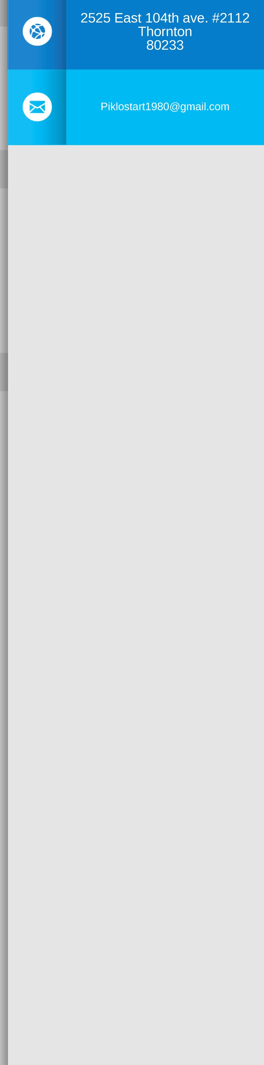
*DIVERSIFIED ELECTRICAL AND CONTROL KNOWLEDGE

*TEAM PLAYER * SOLO SKILLS A+
*ALL IF NOT MOST APPLICABLE TOOLS OF TRADE. *SCISSOR LIFTS,AERIAL BOOM LIFTS FORKLIFTS AND
CRANES.RIGGING AND BOOMING
*RESIDENTIAL.COMMERCIAL.INDUSTRIAL.
This resume is made with Free Resume App
720 440 0517
2525 East 104th ave. #2112
Thornton
80233

