RESUME

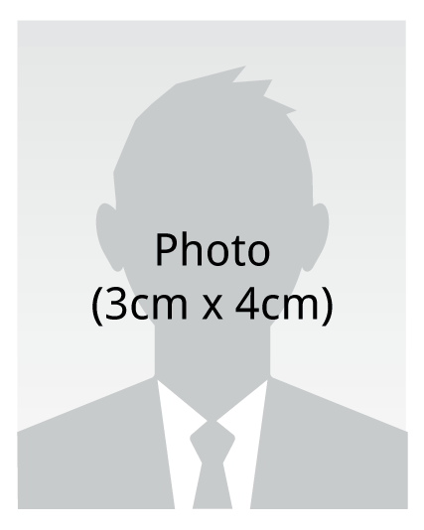 | Name | Eduardo Mendoza Catalan
 | Social Security number | 838-09-8128
 | Address | 3119 Triana Blvd
 | Telephone number | (714) 767-0285
 | E-mail | eduardo.mendoza46@hotmail.com

Education |  | S.R. Butler High School. High school diploma  Huntsville, Alabama.
Experiencs |  | AAFI  Finisher and some pressbrake skills
Language Ability |  | Fluent English and fluent Spanish
Other skills |  | Drywall finisher
Community
Awards
Personal
Etc.

