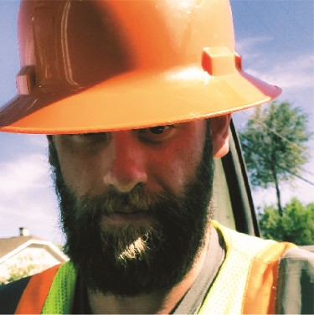
LAWRENCE MATTHEW

REES
7350 W Eastman PI Lakewood CO 80227
303 746 0621 | matt23.Ir@gmail.com
EXPERIENCE
, LaborMax
06/01/2079 - Current
Laborer/Flagger
Lane/Road closures, events, flagging. Traffic control
- Goins Automorive
07/01/2077- 06/07/2017
Automotive Technician
Bumper to Bumper mechanics.
- Isle casino hotel blackhawk
2075-2076
Security Guest Saftey
- U.S Army
04/11/2008 - 02/70/2015
Combat Engineer
EDUCATION
- Clear Creek High School
2007
Diploma

