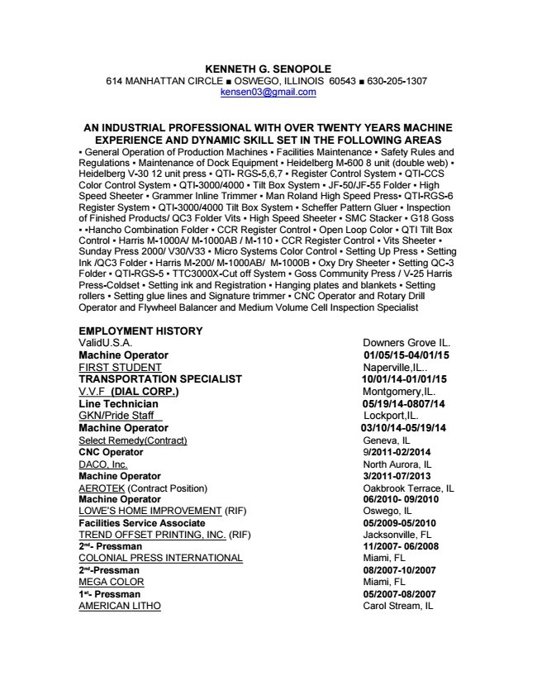

KENNETH G. SENOPOLE 614 MANHATTAN CIRCLE ■ OSWEGO, ILLINOIS 60543 ■ 630205-
1307 kensen03@gmail.com
AN INDUSTRIAL PROFESSIONAL WITH OVER TWENTY YEARS MACHINE EXPERIENCE AND DYNAMIC SKILL SET IN THE FOLLOWING AREAS
▪ General Operation of Production Machines ▪ Facilities Maintenance ▪ Safety Rules and Regulations ▪ Maintenance of Dock Equipment ▪ Heidelberg M600 8 unit (double web) ▪
Heidelberg V30 12 unit press ▪ QTI RGS5,6,7 ▪ Register Control System ▪ QTICCS Color
Control System ▪ QTI3000/4000 ▪ Tilt Box System ▪ JF50/JF55 Folder ▪ High Speed Sheeter ▪
Grammer Inline Trimmer ▪ Man Roland High Speed Press▪ QTIRGS6 Register System ▪ QTI3000/4000 Tilt Box System ▪ Scheffer Pattern Gluer ▪ Inspection of Finished Products/ QC3
Folder Vits ▪ High Speed Sheeter ▪ SMC Stacker ▪ G18 Goss
▪ ▪Hancho Combination Folder ▪ CCR Register Control ▪ Open Loop Color ▪ QTI Tilt Box
Control ▪ Harris M1000A/ M1000AB / M110 ▪ CCR Register Control ▪ Vits Sheeter ▪ Sunday
Press 2000/ V30/V33 ▪ Micro Systems Color Control ▪ Setting Up Press ▪ Setting Ink /QC3
Folder ▪ Harris M200/ M1000AB/ M1000B ▪ Oxy Dry Sheeter ▪ Setting QC3 Folder ▪ QTIRGS5 ▪
TTC3000XCut off System ▪ Goss Community Press / V25 Harris PressColdset ▪ Setting ink and Registration ▪ Hanging plates and blankets ▪ Setting rollers ▪ Setting glue lines and Signature trimmer ▪ CNC Operator and Rotary Drill Operator and Flywheel Balancer and Medium Volume Cell Inspection Specialist
EMPLOYMENT HISTORY ValidU.S.A. Downers Grove IL. Machine Operator 01/05/1504/01/15 FIRST STUDENT Naperville,IL.. TRANSPORTATION SPECIALIST 10/01/1401/01/15 V.V.F (DIAL CORP.) Montgomery,IL. Line Technician 05/19/140807/14 GKN/Pride Staff Lockport,IL.
Machine Operator 03/10/1405/19/14 Select Remedy(Contract) Geneva, IL CNC Operator
9/201102/2014 DACO, Inc. North Aurora, IL Machine Operator 3/201107/2013 AEROTEK
(Contract Position) Oakbrook Terrace, IL Machine Operator 06/2010 09/2010 LOWE’S HOME
IMPROVEMENT (RIF) Oswego, IL Facilities Service Associate 05/200905/2010 TREND
OFFSET PRINTING, INC. (RIF) Jacksonville, FL 2nd Pressman 11/2007 06/2008 COLONIAL
PRESS INTERNATIONAL Miami, FL 2ndPressman 08/200710/2007 MEGA COLOR Miami, FL
1st Pressman 05/200708/2007 AMERICAN LITHO Carol Stream, IL

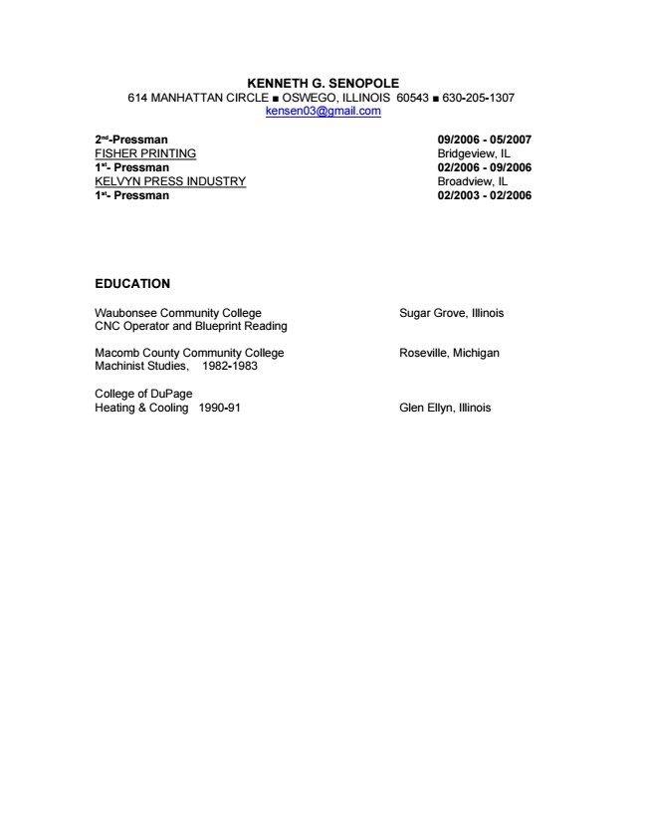

KENNETH G. SENOPOLE 614 MANHATTAN CIRCLE ■ OSWEGO, ILLINOIS 60543 ■ 630205-
1307 kensen03@gmail.com
2ndPressman 09/2006 05/2007 FISHER PRINTING Bridgeview, IL 1st Pressman 02/2006
09/2006 KELVYN PRESS INDUSTRY Broadview, IL 1st Pressman 02/2003 02/2006

EDUCATION
Waubonsee Community College Sugar Grove, Illinois CNC Operator and Blueprint Reading
Macomb County Community College Roseville, Michigan Machinist Studies, 19821983
College of DuPage Heating & Cooling 199091 Glen Ellyn, Illinois

