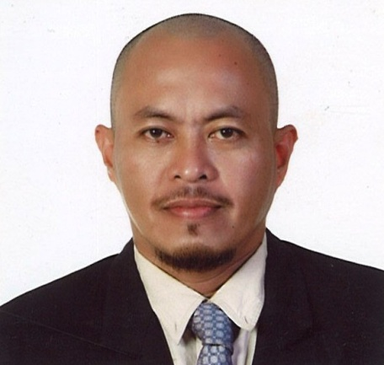
Name: DOMINADOR O. GLUDO

Address: Riyadh, KSA
Date of Birth: April 15, 1973
Contact No: +639495623385
Permanent Address: Leyte, Philippines
Email Add: dominador.gludo@yahoo.com
Driving License: Professional

Objective: seeking for a Job as a Welder Fabricator in a well-Stable Company to apply my knowledge and skills.

Work Experience:
Oct., 2010-Oct.2012 MASCO
Riyadh, KSDA
Job Title: Welder/ Fabricator
Duties:
: Perform standard welding procedure using SMAW, FCAW & GMAW welding process.
: Perform Oxygen-Acetylene Gas cutting and Plasma cutting process.
: Perform Mechanical Installations, Fabrication and Pipe Fittings.
: Determine materials to be use and analyze drawing.
: Handle Power tools and Safety.

March, 2003-June, 2009 NATIONAL TRANSMISSION CORPORATION
Leyte, Philippines
Job Title: Welder/fabricator
Duties:
: Perform Standard welding procedure using SMAW, FCAW & GMAW welding process.
: Perform Mechanical Installation and Fabrication.
: Perform Oxygen-Acetylene Gas cutting process.
: Determine materials to be use and analyze drawing.
: Handle Power Tools and Safety.

Work Experience:
Sept., 2001-Feb., 2003 NATIONAL POWER CORPORATION
Leyte, Philippines
Job Title: Welder
Duties:
: Perform Standard welding procedure using SMAW, FCAW & GMAW welding process.
: Perform Mechanical Installation Fabrication.
: Perform Oxygen-Acetylene Gas cutting process.
: Determine Materials to be used and analyze drawing.
: Handle Power Tools and Safety.

Education Details:
Oct., 2009- Nov., 2009 BMC Training Center for Welding and Fabrication
Cebu, Philippines
Shielded Metal Arc Welding

Oct., 1996 Philippine State College of Aeronautics
Cebu, Philippines
Bachelor of Science in Aircraft Maintenance Engineering

March, 1995 Philippine State College of Aeronautics
Cebu, Philippines
Associate in Aircraft Maintenance Engineering

March, 1990 ORMOC City High School
Leyte Philippines

March, 1986 Punta Elementary School
Leyte, Philippines

Additional Skills:
: knows Mechanical Installation.
: Knows pipefitting and Fabrication.
: Can read and understand Drawing and Blueprints.
: Can Operate Fork lift and Bobcat.
: Light duty vehicle driver.

Training/ Seminar:
Sept.18, 2009 Workplace Safety Seminar
Cebu, Philippines
Engr. ALLAN C. DINAMPO

Sept. 05, 2009 Proper Care and Maintenance of Power Tools
Cebu, Philippines
Mr. ANTHONY LIM

August 06, 2008 Defensive Driving Seminar
Engr. EDGAR J. EDIZA
National Transmission Corp.
Leyte, Philippines

April 07, 2006 Defensive Driving Seminar
Engr. EDGAR J. EDIZA
National Transmission Corp.
Leyte, Philippines

License/ Certification:

Welders Qualification Test HL045-B3-10-0005
National Certificate II (SMAW) 10070202000521
Cert. of Training (SMAW) B6GH-4-015-2009
Automotive Servicing NC II 447
CSC Automotive Mechanic MC II 2608237
CSC Professional 08081434/96-105781

References:
Engr. Mohamed HASSAN Engr. ELPIDIO M. MAMASIG Jr.
Regional/Project Manager Assistant Manager
MASCO, AL- ZULFI WPP, KSA MASCO, Production Department
Riyadh, KSA
Engr. Mohamed OMAR WALID
Regional/Project Engineer
MASCO, Al- ZULFI WPP, KSA

I hereby certify that all the information written above is true and correct.

DOMINADOR O. GLUDO

