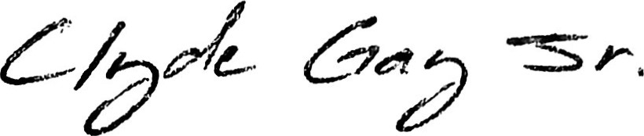
12150 Washington center pkwy unit 10-204 Thornto, Co, 89241 , Denver, CO 80229 • (318)871 mrgay914@gmail.com

PROFESSIONAL SUMMARY
Proficient in maintaining smooth and efficient mechanical systems. Systematic professional with a keen eye for details. strong focus on performance improvements and skill in root cause analysis.

SKILLS
• Power and hand tool | • Safety procedures knowledge
. Forklift | • Overhead crane operations
- Strong mechanical skills  - Troubleshooting skills | • Blueprint layout

WORK HISTORY
Mechanical Maintenance For Liquid Dosing Machine
Vestas Blades Brighton - Brighton, CO 08/2014 - Current
- Maintained compliance with company standards to perform all maintenance activities.
- Troubleshot and diagnosed problems with mechanical and electrical systems and equipment.
- Completed documentation for recordkeeping and customer use.
- Implemented changes requested by designers, owners or inspectors.
- Performed basic machine set up.
- Used hoists and cranes to lift work pieces to machine.
- Applied chemical solutions and used polishing machines to cle all installation surfaces, equipment, tools, work sites and storage areas. Promoted shop safety by working in a safe manner.
- Promoted shop safety by working in a safe manner.
Truss Builder
Ward Vonne Inc - Commerce City, CO
04/2009 - 07/2014 • Measured and cut materials in adherence to schematic drawings.
- Used hand tools to change wom cutüng tools.
- Followed company procedures to maintain work environment in a neat and orderly condition.
- Accurately read, understood, and carried out written instructions.
- Loaded and unroaded building materials used for construction.
- Used precision measuring instruments, templates, and fixtures to measure dimensions of finished work pieces.

EDUCATION
High School Diploma
Coushatta High School - Coushatta, LA
2000
C.

