nextSource / BASF Procedures:
- CMG is engaged by BASF/nextSource – recruit for Packager, Mixer, or Material Handler
Recruiting:
- Verify that the Packager position is active on Newton.
- Post ad on Craigslist, specify whether night or day shift position is preferred. Make sure to include the Newton application link or www.CMGApply.com in the ad re-directing the applicants to our job posting page.
- Filter through the applications specifically looking for Assembly or Packaging experience. Also look for longevity in a company (longer than two years). Steer clear of Clean room Assembly, CoorsTek and Swift employees (Client has not had good luck with these applicants in the past).
Phone Screen:
- In the phone screen try to get a good feel for what they are looking for. At this time explain to the applicant what we are looking for such as assembly/packaging experience, longevity in employment. Confirm the dates they listed from previous employment. Some other questions to ask are:
- Can you lift 50 lbs on your own?
- Have you worked 12 hour shifts before? If so, standing?
- We run a full background and drug screen, are there any felonies or misdemeanors that will show up on your record? If you were to take a drug screen tomorrow would it come back clean?
- Can you provide proof of a high school diploma or GED?
- What shift would you prefer if both are open?
- After getting a feel for the applicant invite them for an interview if you feel like they would be a good candidate
Interviews:
- Set up in person interviews with the applicants before inviting them to the tour.
- During the interview discuss resume and find out details of previous positions, top wage, shifts (8/10/12 hour shifts) and reason why no longer employed at each company.
- Be sure to look for highly interested applicants and read their body language as far as sitting back in their chair, seeming too relaxed or too nervous (Supervisors for BASF do not like this behavior). Ask them to relate previous experience to the Assembly/Packaging position, i.e., standing for long periods of time at one station, ability to work alone and be responsible for a certain amount of product to be produced within an allotted amount of time. Do they help their fellow co-workers and watch out for their own safety and their co-workers. Some examples of questions would be:
  - An example of a potential safety incidence and what did they do about it? You’re looking for a time when someone almost stuck their hand in a machine that could potentially harm them and the applicant stopped it before anyone got hurt. Or a pallet was about to fall on a co-worker and the applicant made the forklift driver aware of it before an accident occurred.
  - What is “Lock out/Tag out”? This is when a machine is not working properly or needs to be cleaned or reset and the applicant or maintenance person locks down the machine with a tag and only the person that locked down the machine can unlock it.
  - Have you ever worked 12 hour shifts and were they standing the entire time? The shifts for BASF are 12 hour shifts and they are looking for applicants that are used to these long shifts standing the entire time.
  - What do you do to support your co-workers? A good answer would be when they were finished with their line they jumped in and helped out a co-worker get caught up. Also help answer any questions the new co-workers might have or tell their co-workers they’re doing a good job and in general be supportive.

Touring the facility:
- Email Gina (Gina.Kinnamon@BASF.com) to ask when she is available for a tour. Typically this is done before you have set up in-person interviews in order to invite the qualified applicants to the scheduled tour.
- The tour lasts approximately two hours and comprises of a short introduction with history of company and what they are looking for in their contractors. Gina will guide the applicants through the facility followed by a 5-10 minute interview with each applicant. The recruiter will sit in on the interviews and briefly discuss whether or not Gina would like to invite the applicant back for a second interview. Gina will give you a reason as to why the applicant is not invited back, whether they bombed the interview, too timid, or previous experience is not what they are looking for, etc.
- While in the interview, if the applicant is invited back to a second interview with the shift supervisor, Gina will let the applicant know and usually gives the time and date to when the applicant needs to report back.
- The applicant is to report to the lobby of the facility and let the person at the front desk know they are there for a second interview.
- Once the applicant has passed the second interview Gina will call and let the recruiter know.
- From there the applicant is placed on a Hot List, or Gina will notify the recruiter as to when the next scheduled orientation will be.

On boarding:
- Applicant will come in and fill out following paperwork:
- Managed Staffing Employment Application
- Managed Staffing Information Form
- Managed Staffing Handbook Acknowledgement Form
- Managed Staffing Payroll & Timesheet Systems Policies & Procedures
- Managed Staffing Equipment Agreement
- Schedule B
- Schedule C (3 pages)
- W4
- I-9
- Authorization For Release of Information For Employment Purposes (back ground check)
- Direct Deposit Application
- Youth Self Attestation Form (If new hire is under the age of 25)
- WOTC Questionnaire (2 pages)
- 8850 Pre-Screening Notice and Certification Request
- Then give New Hire Medical Services Authorization form and map to Health One (drug screen), make sure location #7 is circled

- CMG initiates background check through Nation Search (CMG expense) and drug screening through Health One (pass through cost to be submitted through TAMS)
**if background check results in assault/battery/resisting arrest or any violent crime document details from conversation with contractor, email to Rebecca Heinrich (Rebecca.Heinrich@partners.BASF.com) at nextSource, Rebecca will email to Gina for approval through legal department, Rebecca will contact CMG with results. During conversation with Contractor discuss what the offense is (misdemeanor or felony), details of what happened, jail time was served, probation, etc.

- CMG will require proof and confirmation of GED/High School Diploma and will provide documentation along with background/drug screening results. When the applicant is filling out onboarding documents ask them to bring a copy of high school diploma or GED for us to copy and submit.
**after completion of Contractors first 30 days nextSource or Gina will request vendor to set up physical to be completed at HealthOne facility (pass through cost submitted through TAMS)
Inputting Contractor into TAMS:
- Once Gina has opened the position to us on TAMS (located on TAMS login homepage). We need to submit the candidate into TAMS.

- In order to submit New Hire into TAMS go to https://basf.nextsource.com/login.phtml. User name is: Corporat Password is: washington290
- Submit candidate into TAMS: When submitting a new candidate into TAMS click on the open job position, click on submit candidate. When filling out the Bill Rate – take the hourly rate and times it by 1.5. (for example $13.00 x 1.5 = $19.50 p/h). The Bill Rate is 50%, nextSource will send out an email for us to accept their negotiated rate. Attach the candidates resume (make sure the resume in a word or .doc format), click on either day or nights for the shift they are working and click “yes” for the candidate is authorized to work in the US. You do not need to fill out any of the information boxes because Gina/BASF has already approved the hire. Click on Post Form. Once you have submitted the candidate nextSource will send an email counter offering our 50% markup, usually they come in at 38% or so (which will be slightly lower than what we will accept, this is their way of negotiating our rates down). Respond to the email with our 40% markup (i.e. $13.00=$18.20 with our markup). nextSource will then accept our offer and create a task order. ***See step 21 to approve task order***

- Once screening results are in and contractor is clear, scan and email forms A, A1, B and all 3 pages of C, to basfonsite@nextsource.com (which will notify Rebecca and Sue) along with candidates name and opening (located in TAMS under number and needs to be included in the subject line of your email). Copy Gina at BASF (gina.kinnamon@basf.com).

- Contractor to fill out Managed Staffing new hire docs, pages 3-5, 8 and 9 of Initial New Hire form and 8850/WOTC form. Email these forms, along with I9, W4 and Direct Deposit, copy of driver’s license plus Social Security card or Birth Certificate to Jennifer at Managed Staffing (jennifer@managedstaffing.com) When emailing Jennifer include the Pay Rate (i.e. $13.00) and the Bill Rate ($18.20).
***After 30 days pay rate will increase by $1.00 p/h effective February 1, 2012***
Notify Jennifer of pay rate increase.
Task Order Approval:
- Once we have received the task order confirmation/notification email you must open up TAMS, click on the “Procurement” tab, click on task order, unconfirmed folder, details, double check to make sure the rate is correct at 40%. (i.e. $12.00 x 1.4 = $16.80 or $12.60 x 1.4 = $17.64) Then confirm the candidate. Also double check to make sure the vendor is able to submit time sheets.
Orientation/Start Date:
- Contractor attends orientation at facility, typically lasts 2.5 hours and contractor will be given PPE’s by BASF, and orientation & start date will be emailed over to recruiter
Time Sheet:
- Employees are paid from Managed Staffing
- Contractors are to fill out time sheets, signed by supervisor and given to Gina
- Hours are emailed to CMG by Gina on Monday mornings
- CMG forwards hours to Jennifer at Managed Staffing and upload into TAMS.
Time Sheet - Must be turned in by Monday at 10:00 MST.
- Create Timesheet in TAMS:
- Before you are able to create a timesheet for an employee, you must first approve the task order created by nextSource. To approve the task order click on Procurement, Task Orders, Unconfirmed, Details, verify rates, confirm.
- Create time sheet for approval (by BASF/Gina and nextSource) by logging into TAMS, click on Accounting, Timesheets, choose employee, enter daily time/shift worked. If worked 12.5 hour day (such as 4:30-5:00) add .5 hours to “non-billable” hours. For the “pm” box, if it’s checked it means “pm” if not check means “am”. Click on calculate, verify total hours, check the certify box and submit timesheet.

***See below for example***
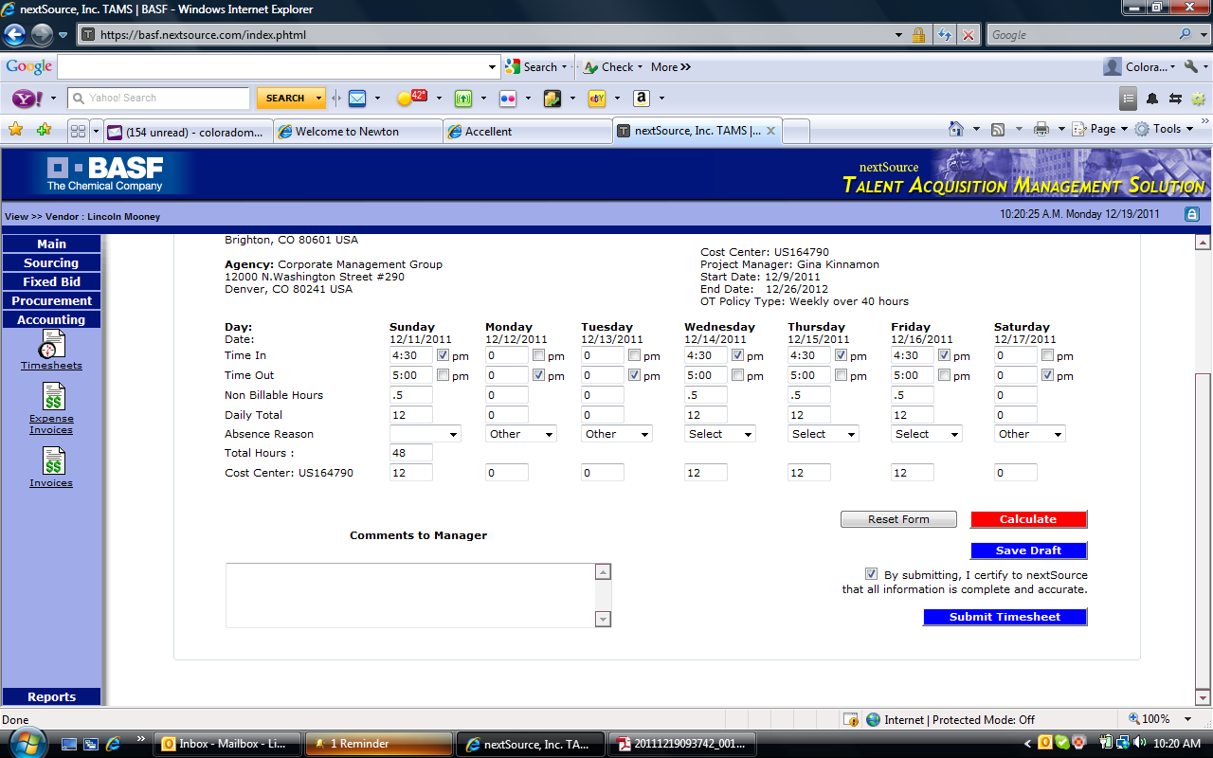
Invoicing: – MUST BE SUBMITTED BY TUESDAY AT 8:00 MST
- Once the Timesheet has been approved by Gina at BASF (usually completed by 3:00 MST Monday afternoons) we can then go in and submit the invoice. In TAMS click on “Accounting”, create invoice, choose company code “US01”, verify the hours are correct, click on continue, enter in the invoice number (today’s date without dashes or spaces, just the number) click on create invoice.
Expense Invoice:
- Only drug screenings are a pass through cost. Upon receipt of the HealthOne invoice we must input the expense into TAMS. Click on Accounting, Expense Invoice, Create Invoice, select US01, click on the correct Contractor, input invoice number (which is the date of the invoice), invoice period does not have to be exact just put in the first week of the Contractors start date, enter expense amount, then in the description enter the breakdown of the cost. Example – HealthOne Screening, Drug Screen-$35, Isacyanat-$25. Click on Continue and the invoice will be submitted.
Notes:
Holiday Pay – New Years Day (12/30/2011), President's Day (2/20) Good Friday (4/6), Memorial Day (5/28), Independence Day (7/4), Labor Day (9/3), Thanksgiving Day (11/22), Day After Thanksgiving (11/23) Christmas (12/24, 25).
If the employee is scheduled to work a holiday they must work and they are paid 12 hours at time-and-a-half plus 8 hours straight time. If they aren't scheduled to work, they are paid 8 hours of straight time. BASF will close down the whole plant 2 days at Thanksgiving and 2 days at Xmas so they are paid 8 hours of holiday for each of those days. Holidays apply to BASF Employees as well as Contract Employees.
Entering Holiday pay into TAMS: (Per conference call on 2/28)
If employee worked on a holiday: Enter the hours as they appear on the time sheet for their worked shifts. In the next available day that they did not work add the 8 hours and change the drop down option to holiday. If the employee did not work on a holiday enter in 8 hours for the day and change the drop down option to holiday. In the note section state the date (mm/dd) you added the 8 hours on and reason ex. – “Hours entered on 2/23 is for the 8 hours holiday pay on 2/20.”

