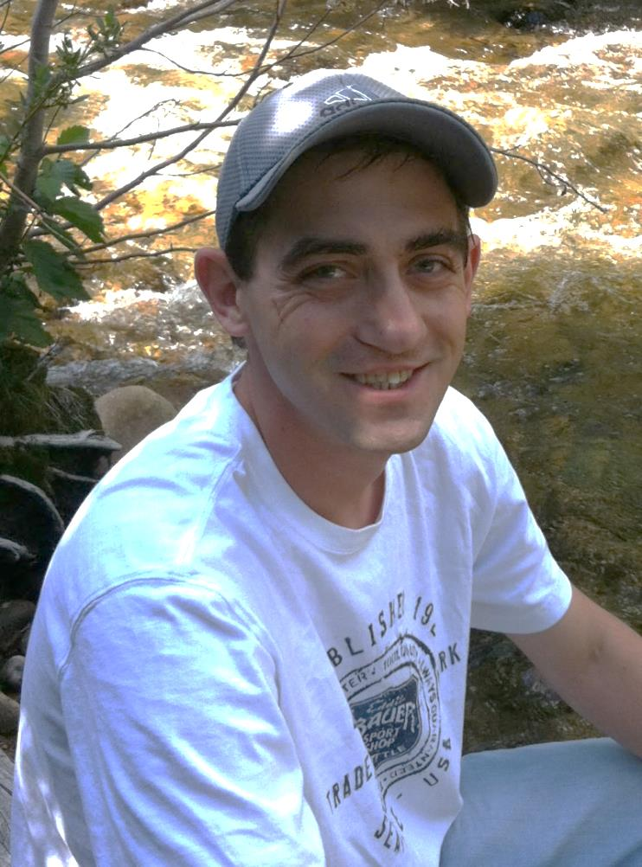
Greetings.

My name is Will Clymer, and I am a CNC Machinist and part time student earning my Bachelor’s degree in Finance. I have 10 years of experience setting up, editing, and running multiple types of machines. I take great pride in my work, and I am very efficient. I am confident you will be pleased with my work and my performance. I look forward to hearing from you.

William Clymer
willclymer@yahoo.com
4251 Cambridge Ave., Broomfield, CO 80020
720-541-4809

Objectives
I am currently a student going to Front Range for my finance degree of which I am looking to finish at CU or Metro State. I’m a well-rounded machinist working my way through school. I take pride in my work and enjoy what I do. My through- put and attention to detail is top notch. I am looking for a company with a bright future for someone like myself. I am dedicated and want to grow with the company. I assure you that you will not be disappointed in my performance.

Education

Front Range Community College (Westminster, CO)
2011 – Present Finance Major

Francis Tuttle Technology (Oklahoma City, OK)
September 2004 – March 2005 Certified CNC Machinist

Oklahoma State University (Stillwater, OK)
August 1999 – January 2000 Basics

Guthrie High School (Guthrie, OK)
August 1995– May 1999 Diploma

Experience

Hirsch Precision | Boulder, CO
CNC Machinist l July 2013- October 2014

Intrex Aerospace
| Louisville, CO
CNC Machinist March 2011 – April 2013
Operation of CNC machines and inspection of own parts while maintaining efficiencies. Also experienced in working with materials ranging from aluminum to inconel.

FIFE Corp. | Oklahoma City, OK
CNC Machinist March 2010- March 2011
Worked as the “Tool Crib attendant” responsible for setting up all tooling for the machines each day. When finished setting up, I operated machines the rest of the day.

Zeco Machine Inc. | Guthrie, OK
CNC Machinist February 2005– May 2009
Proficient in set up, operation, part inspection and manual programming of CNC machines. Also proficient in manual lathes and mills.

Skills
Experienced in the following machines:
- Okuma ( LU-15 twin – turret, cadet, etc.)
- Mori Seiki ( NZL-2500 twin – turret, SL- 150, SL-200, etc.)
- HAAS VF7
- Heineman DN-400
- Fadal
- Cincinatti
- Hardinge
- Puma
- Gun/Drill
- Manual Mills and Lathes

References
Mark Calistro- Lean Coordinator
250 S. Finch
Lafayette, CO 80026
303-746-6697

Mike Miller – Lead man
753 Locust Ave,
Lochbuie, CO 80603
720-985-8658

George Frisbee
Industrial Engineer for FIFE Corp.
Oklahoma City, OK 73126
405-755-1600

Robert Neria – Co-worker (25+yrs experience)
2417 ½ S. Division St.
Guthrie, OK 73044
405-627-3776

Craig Hoisington – Co-worker (25+yrs experience)
6600 S. Midwest Blvd.
Guthrie, OK 73044
405-535-5739

Dennis Phillips – Co-worker (25+yrs experience)
1108 Copperfield Dr.
Edmond, OK 73003
405-341-7390

