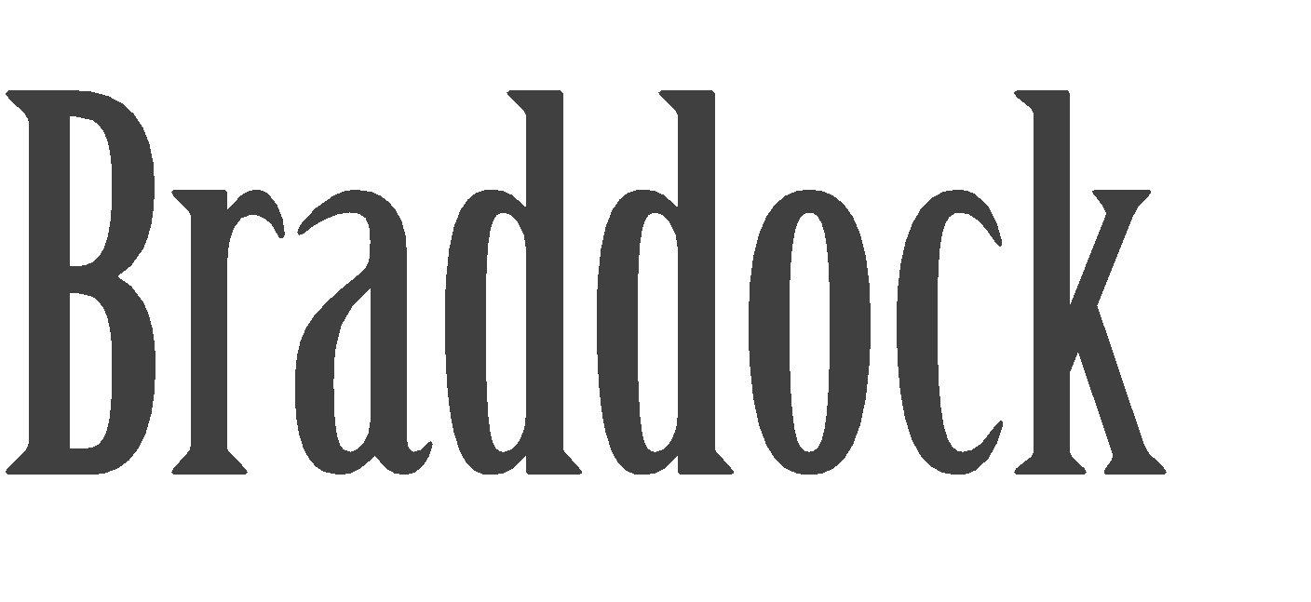

Administrative Assistant

ABOUT
I’m an Administrative Assistant, with a background in medical and manufacturing environments. Quality assurance, purchasing, shipping, and receiving are core processes of my paraprofessional foundation. I’m currently enrolled in my undergraduate studies, working on a path towards alternative and environmentally sound funerary practices and consumer advocacy.
SKILLS
- Professional Telephone Etiquette
- Understanding of Confidentiality
- Medical Transcription
- Extensive use of Microsoft Office Suite
- Scheduling & Calendar Management
- Office Operations Coordination
- Medical Chart Management
- Typing Proficiency (70+ WPM)
- Shipping, Receiving, & Purchasing Oversight
- Invoicing, AP/AR Exposure & Assistance
- Inventory & Spreadsheet Reports

WORK EXPERIENCE
EDUCATION
Normandale Community College
June 2014 – Present, Liberal Arts

Aslan Institute
Midwifing Death Workshop Lyndall Johnson, MA (Registered) August 2015

4Keeps Mindfulness Workshop Wendy Selnes, MA, BCBA
April 2015
CAMBRIA – IT Administrative Assistant (02.2013) Responsible for complete oversight of purchase manifestation. Establishing and maintaining copacetic shipping, receiving, and purchasing procedures. Executive and vendor correspondence. Internal and External call volume management.
Scheduling and calendar management of Cambria IT leadership & Sun Country CIO, as well as department meetings and event coordination. All general office operation. Occasional assistance in invoicing & AP/AR procedures. Intermediate exposure to ERP/Adage, Kaseya, Service Manager, and TrackIt. Extensive use of Microsoft Suite.
CONTACT
Karyn Braddock 746 6th Ave West
Shakopee, MN 55379 karynbraddock@gmail.com 320.583.4606

CAMBRIA - Quality Assurance Technician (07.2011) Responsible for multi-point assurance inspections to ensure that the product is of the highest quality for the customer. Testing and inspection on raw and final product using scales, calipers and miscellaneous gauges. Perform load, stress, and performance testing and analyzing results as well as participate in defect reviews. Basic administrative support, Microsoft suite, and mathematic calculations. Ensuring efficient rapport with all other departments. Crane, Respirator & Fork Lift Certified.
EXTRA
Member of the following: Secular Student Alliance National Home Funeral Alliance Minnesota Threshold Network Funeral Consumer Alliance
TARGET – Front End Associate
AMERICINN LODGE & SUITES – Front Desk/Audit BURNS MANOR NURSING HOME – Ward Secretary

**References available upon request

