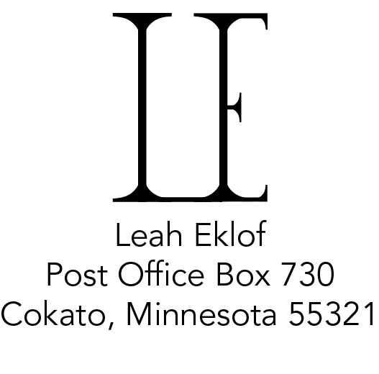
EDUCATION
2011–2015 BFA Graphic Design, Concordia University, Seward, Nebraska
Marketing minor

WORK EXPERIENCE
2013–2015 Graphic Design Intern at Marketing Department,
Concordia University, Nebraska, Seward, Nebraska
2012–2014 Gallery Worker at Marxhausen Gallery,
Concordia University, Nebraska, Seward, Nebraska
2013 Church Secretary at Our Savior’s Lutheran Church,
Hutchinson, Minnesota

ACTIVITIES/ACHIEVEMENTS
2011–2015 Achievement Award, Concordia University, Nebraska, Seward, Nebraska
2011–2014 Member of the art club Concordia University, Nebraska, Seward, Nebraska
2011–2013 Marxhausen Endowment Award, Concordia University, Nebraska,
Seward, Nebraska
2014 The Wayne and Wanda Lillich Endowment, Concordia University, Nebraska,
Seward, Nebraska
2014 Honorable Mention, Best of College & High School Photography Contest sponsored by NIKON, Serbin Communications INC., Santa Barbara, California
2014 Published in Photographer’s Forum Magazine and Best of College and High School Photography 2014, Serbin Communications INC.,
Santa Barbara, California

JURIED EXHIBITIONS
2015 Bachelor of Fine Art Senior Thesis Exhibition, Marxhausen Gallery,
Seward, Nebraska
2013–2015 Annual Student Art Show, Marxhausen Gallery, Seward, Nebraska
2014 Eleventh Annual NCIF/O’Keefe Elevator Company Art Show, Omaha, Nebraska
2013 Tenth Annual NCIF/O’Keefe Elevator Company Art Show, Omaha, Nebraska
2013 Concordia Award Winner’s Show, Wolfram Gallery, St. Louis, Missouri

SOFTWARE PROFICIENCY
Adobe Photoshop CC, Adobe Lightroom 4 & 5, Adobe InDesign CC, Adobe After Effects CC, Adobe Illustrator CC, Adobe Dreamweaver CC, Adobe Acrobat, Adobe Premiere Pro CC, Adobe Media Encoder CC, Microsoft Office

