Resume

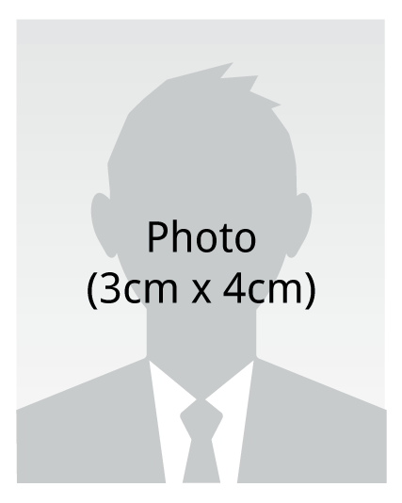 | Name | Donald L Young
 | Social Security number | 611-
 | Address | 1316 s meadow lane colton ca, 92324
 | Telephone number | 909-910-2572
 | E-mail | Semajdad15@gmail.com

Education |  | Locke high school( 03-07)  - High School Diploma
Experiencs |  | Kimco staffing (08/-10-2014)  - Warehouse production packaging, shipping, labeling, rf machines, palletizing, shrink wrapping.
Experience |  | DIAMOND STAFFING (10-PRESENT)  - Unload material , palletize and load cargo onto trailers using pallet jacks and forklifts
Licenses |  | Class c , refinery saftey operater card

