Sean Thomforde
26283 370th St.  Goodhue, MN 55027  (651) 380-5301  sean.thomforde@gmail.com

Objective
 |  |  | To obtain a job opportunity with a quality organization, therefore, I can gain great experience to enhance my knowledge and understanding in order to become successful for the future.
Experience
May 2014 – Oct. 2014 |  |  | Grand Targhee Resort Alta, WY 40hrs/wk
 |  |  | Mountain Operations Crew
 |  |  | ● Cut and maintained ski runs while operating vehicles throughout the resort.
● Preformed set up and tear down for music festivals.
● Interacted with guests on a regular basis and provide guest service.
● First Aid/CPR certified and assisted with mountain emergencies.
May 2013 – Aug. 2013 |  |  | Rochester Honkers Baseball Rochester, MN 90hrs/wk
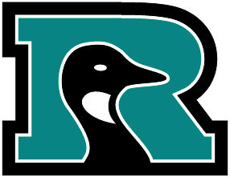 |  |  | Game Operations Intern
 |  |  | ● Preformed stadium set up and tear down.
 |  |  | ● Concession management: game day staff, main concessions, party decks.
 |  |  | ● Inventory management, stocking, and control.
 |  |  | ● Vendor communications, fan relations/promotions, and general office duties.

July 2012 – Aug. 2012 Minnesota Vikings Mankato, MN 50hrs/wk
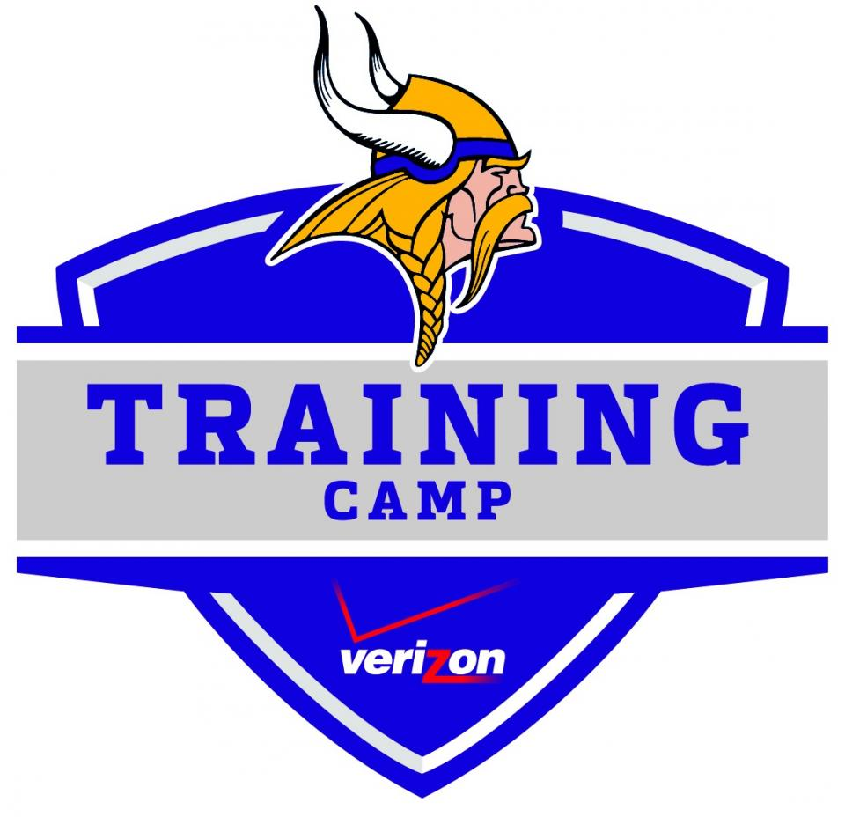
Marketing Intern (Training Camp)

- Provided guest service for children to corporate sponsors.
- Preformed set up and tear down of venue with our team.
- Interacted with kids in the Vikings Village.

- Teamed up with operations department and preformed clean up of teams dorm.
Education
Fall ’10 –Sum. ‘13 |  |  |  |  |  | Minnesota State University, Mankato Mankato, MN
 |  |  |  |  |  | Bachelor of Science Degree: Sport Management
 |  |  |  |  |  | Minor: Marketing
 |  |  |  |  |  | Related Coursework: event management, sport marketing, sport administration, sport
 |  |  |  |  |  | facilities, sport ethics, financial aspects of sport, etc.
Fall ’08 –Spring ‘10 |  |  |  |  |  |  | SoSouth Central College North Mankato, MN
Activities and Honors
- On marketing team for 2012 MSU Scholarship BBQ
- For class, our group pitched best marketing campaign to a local business
- As a group put together a concert event to raise money for Diabetes Research
- Assisted with coaching youth basketball and flag football
- Sold tickets for multiple sport management events
- Intramural sports: flag football, basketball, softball
- Made Dean's list at MSU and SCC

● | Microsoft Office programs | ● | Strong work ethic
● | Communication | ● | Problem solving
● | Guest services | ● | Adaptable & flexible
Skills

