CHRISTOPHER RYAN ANDERSON
chris.r.anderson5@gmail.com
6766 W. 96th Ct, Westminster, CO 80021
(308) 940-2650

EDUCATION
University of Nebraska-Lincoln Graduation: December 2012
Bachelor of Science in Business Administration
Major: Business Administration / Management

PROFESSIONAL SKILLS

- Interpersonal Communication
- Customer Centric Thinking
- Organization
- Adaptable / Flexible
- Apt / Receptive
- Team Work
- Trainable
- Strategic Thinking

RELEVANT EXPERIENCE
BonnaVilla Homes Aurora, Nebraska
Electrical Tester August 2013 – August 2014
- Worked 50 hours a week
- Performed various electrical tests to ensure every house is wired properly and all devices work
- Used troubleshooting techniques to correct shorts and improper wiring
- Reviewed blueprints and quotes
- Coordinated with multiple departments to resolve any and all issues
- Trained new employees to adhere to the guidelines required to perform the position
Hy-Vee Inc. Grand Island; Lincoln, Nebraska
Meat Service Manager August 2010 – July 2013
- Worked 40 hours a week managing daily operations including: production, training, promotions, and marketing
- Trained new employees on prepping procedures, meat cutting, machine operations, and customer service skills
- Conducted customer satisfaction survey which helped build a stronger customer service team
- Promoted products with in-store advertisement and announcements leading to increased sales
- Observed inefficiencies and applied procedures to simplify daily operations and increase customer satisfaction
- Ensured customers’ needs were met and all problems were solved effectively

Vector Marketing Lincoln, Nebraska
Assistant District Manager February – July 2010
- Worked a minimum of 70 hour a week
- Promoted from Sale Representative to Assistant District Manager in only two months due to high sales performance and leadership skills
- Conducted group interviews with 5-15 candidates
- Performed 8 hour training sessions with groups of 10-20 sales representatives teaching sales and negotiation
- Received The President’s Award based off sales exceeding $5,000 in less than 15 appointments
- Assisted sales representatives with appointments by providing closing and negotiation techniques
- Balanced office cash flows in excess of $5,000 a week
- Kept record of sales and appointments of over 30 representatives using Microsoft Excel

CHRISTOPHER RYAN ANDERSON
chris.r.anderson5@gmail.com
1230 West Ryons Street, Lincoln, NE 68522
(308) 940-2650

REFERENCES

Mr. Brian Barker
Plant Manager
BonnaVilla Homes
(402) 694-5250

Mr. James Dunham
Production Supervisor
BonnaVilla Homes
(402)694-5250

Mr. Dan Brayton
Production Lead
BonnaVilla Homes
(402)694-5250

Mr. Brad Waddingham
Assistant Meat Department Manager
Hy-Vee Inc.
(402) 853-2015

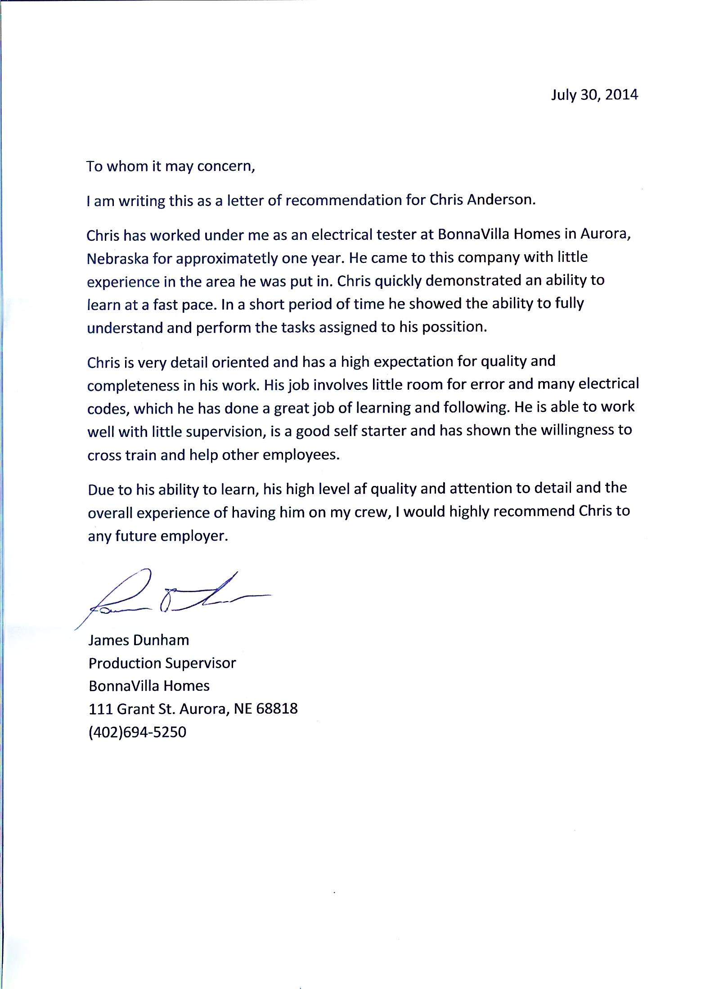

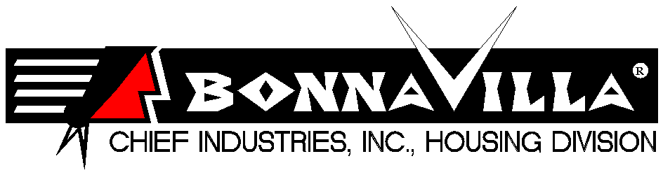
July 27, 2014

It is my pleasure to recommend Chris Anderson for any position within your company or organization. Chris worked for us at BonnaVilla for about a year, coming to us with minimal experience. He is a self- starter that has the ability to pick up and retain experience very quickly.
Chris started out working as an electrician’s helper and within a very short time was able to move into the trouble shooting/testing position. He was able to keep up doing this by himself, when prior to Chris starting we had two people doing the same job. He seems to have a drive to get the job done right the first time virtually eliminating rework.
I would consider Chris to be an asset to any company with his strong work ethic and positive can do attitude. He is welcomed to come back to us at any time if he chose to do so.
If I can be of any further assistance please contact me at the numbers below.

Brian Barker Plant Manager BonnaVilla Homes 111 Grant St. Aurora, NE. 68818 (402) 694-0770 Direct line (715) 415-4408 Cell Phone Brian.barker@chiefind.com

