RESUME

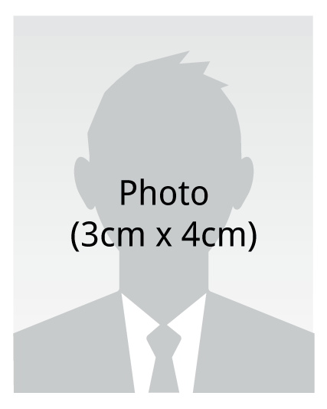 | Name | Yassin I Hassan
 | Social Security number
 | Address | 10641 Smetana Rd #105, Minnetonka, MN 55343
 | Telephone number | 612-963-5131
 | E-mail | Saanwaaye@gmx.com

Education |  | Penn foster high school 2007, mctc general education
Experiencs |  | Teleplan wireless - Quality control 2000-2005  Neometric - production lead 2006-2010  Iwco - material handler 2010-2014  Arrow electronics 2014-2015
Language Ability |  | Fluent in English and Somali ,  - TOEFL score of nearly 600 ( April, 2007)
Other skills |  | Basic computrer skills, Typing 45 wpm, Data entry, forklift certifications sit-downs, stand-ups, tank, riders, and other ones
Community |  | Volunteer work  - SCM - helping people with applications and job searches
Awards |  | Employment Action  - Leadership skills award
Personal |  | Sports  - Tennis, swimming, Workouts, soccer, basketball, running 35 minutes
Reference |  | Kevin 651-602-0789  Charles 651-895-4644  Simon 952-288-8590

