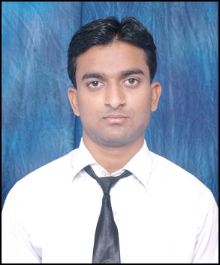
RESUME

MOHD GHAZI KHAN
Guiyan Bagh Nai Abadi Near Tile
Wali Masjid, Moradabad:244001
U.P, India.
Mobile: +91-9760443095.
mohdghazikhan@gmail.com
Objective: To give my engineering career a solid start by joining eminent and highly professional mechanical company and contribute to the success of the company by outstanding performances and thereby advancing my career.
Summary of Qualifications:

- Substantial talent in achieving critical solutions.
- Knowledge of fundamental and uncommon talent of obtaining highly efficient task.
- A high tendency and capability to suit to the high paced and largely pressurizing work environment at a mechanical development organization.
- Interesting in treating modern machines and working environment.
Academic Qualification:
QUALIFICATION | SESSION | COLLEGE/SCHOOL | DIVISION
INTEGRATED B.TECH+MBA (DUAL DEGREES) | 2010-2014 | T.M.U | FIRST
INTERMEDIATE (P.C.M) | 2008-2009 | H.M.I.COLLEGE | SECOND
HIGH SCHOOL | 2006-2007 | H.M.I.COLLEGE | SECOND

Academic Training:

- Industrial training of four weeks in Mechanical Workshop, N.E.Railway, Gorakhpur during 15 June 2012 to 5 July 2012.
- Industrial training of six weeks in BHARAT HEAVY ELECTRICALS LIMITED. RANIPUR, HARIDWARE during 20 June 2013 to 31 July 2013.
Extra-Curricular:

- Member of NSS (National Service Scheme) at intermediate level in 2009.
Interests and Hobbies:

- Traveling.
- Playing cricket.
- Computer Gaming
- Reading (Academic books).
Personal Details:
Father name: Mr. Mohd Jan Khan.
Mother name: Mrs. Nasreen Khan.
Date of Birth: 08 / 15 / 1992
Marital status: Single
Job status: Fresher

Place: MORADABAD.
Date: MOHD GHAZI KHAN.

